2025 MIDSUMMA CARNIVAL SOCIAL STORY

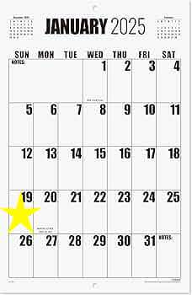

It is the 19th of January, 2025. I am going to an outdoor celebration called Midsumma Carnival. Midsumma Carnival is part of Midsumma Festival: an arts festival that celebrates Queer art and culture.

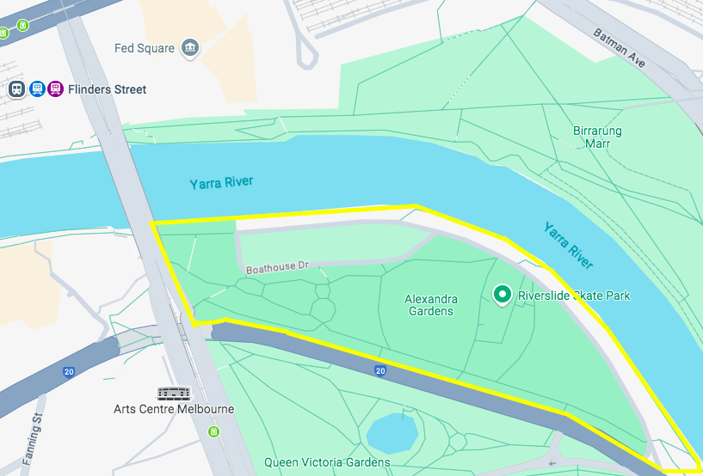

Midsumma Carnival is in Alexandra Gardens, near Flinders Street Station.

If I don’t like crowds, I should arrive at Alexandra Gardens at 11am when there is enough space to walk around without anyone bumping into me. It starts to get crowded at 1pm and at 3pm it gets really crowded.

WHAT TO BRING

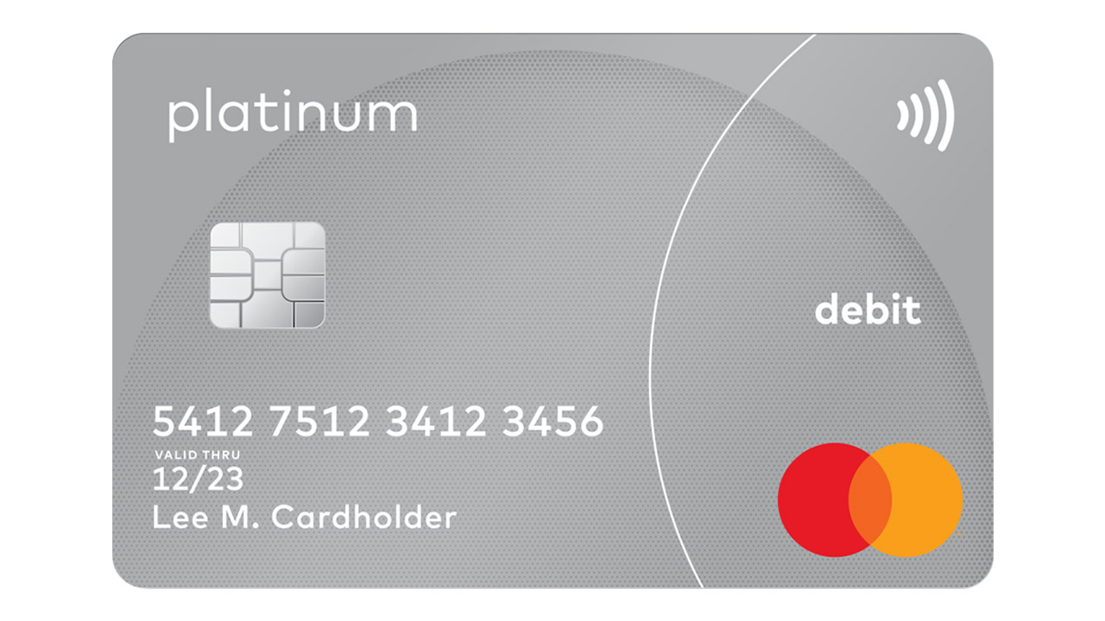

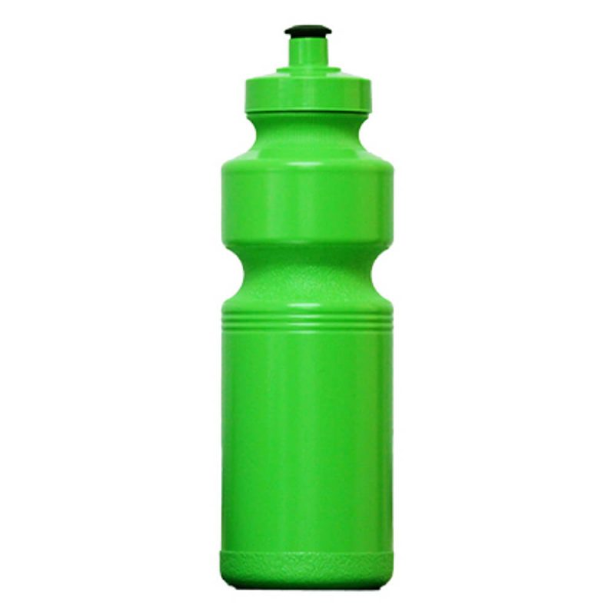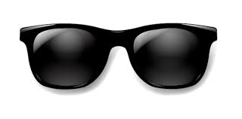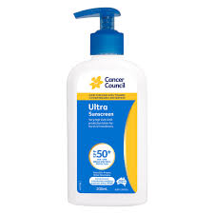

I can bring:

- A Myki if I am travelling by public transport to Flinders Street Station
- Food
- Credit or Debit card, or money, if I want to buy food
- Credit or Debit card if I want to buy an alcoholic drink (the bars will not accept cash)
- Photo ID that proves I am 18 years or older
- My phone
- Fidgets
- A water bottle, hat, sunglasses and sunscreen because it will be hot

I cannot bring:

- Glass bottles or containers

WHAT TO WEAR:

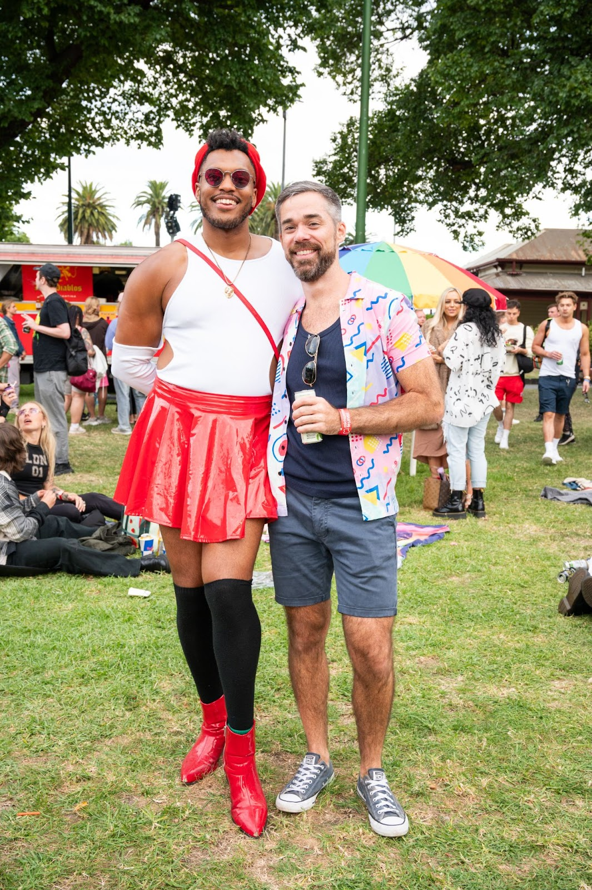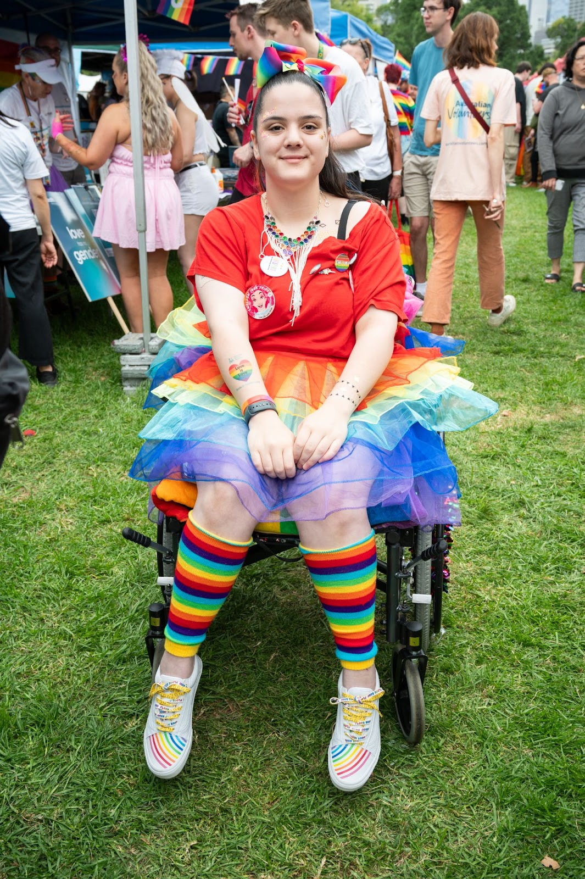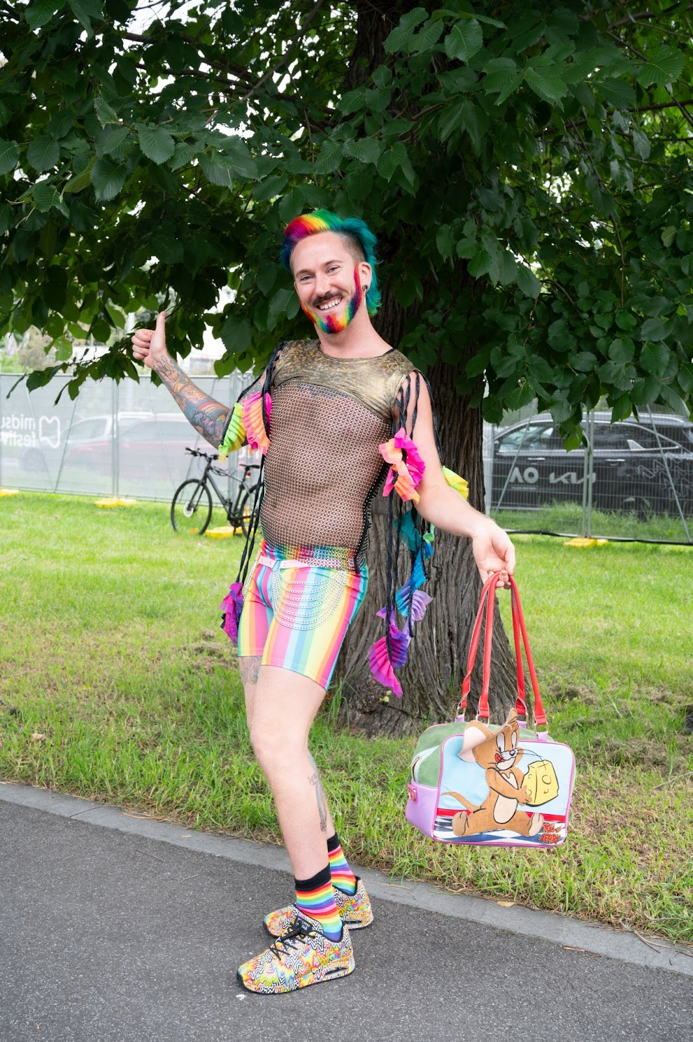

Lots of people at Carnival express themselves with their clothes. I can wear party clothes if they help me express myself. Or I can wear casual clothes.

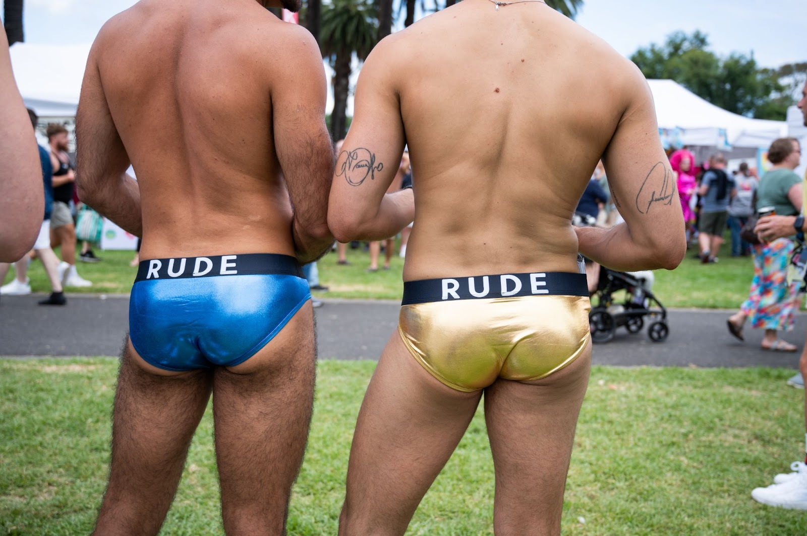

I understand that at Carnival, some of the social rules about clothes are similar to the swimming pool: it’s OK for people to show more of their body than usual, but it’s not OK to show more than what they show when they’re swimming at the pool.

HOW TO GET TO CARNIVAL

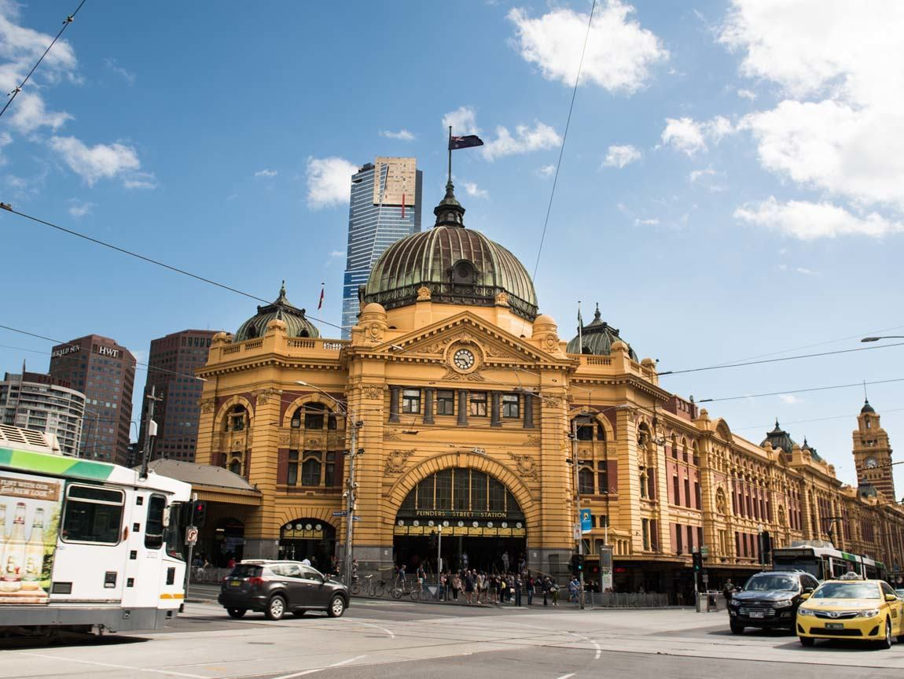

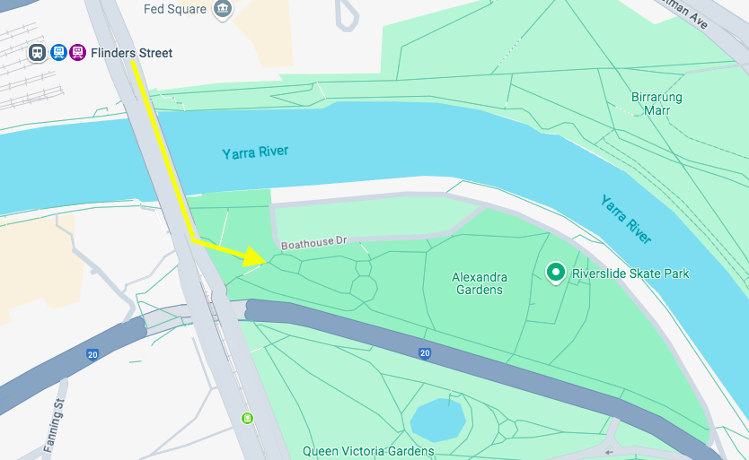

I can walk from Flinders Street Station to Alexandra Gardens. It takes 5 minutes.

ENTERING CARNIVAL:

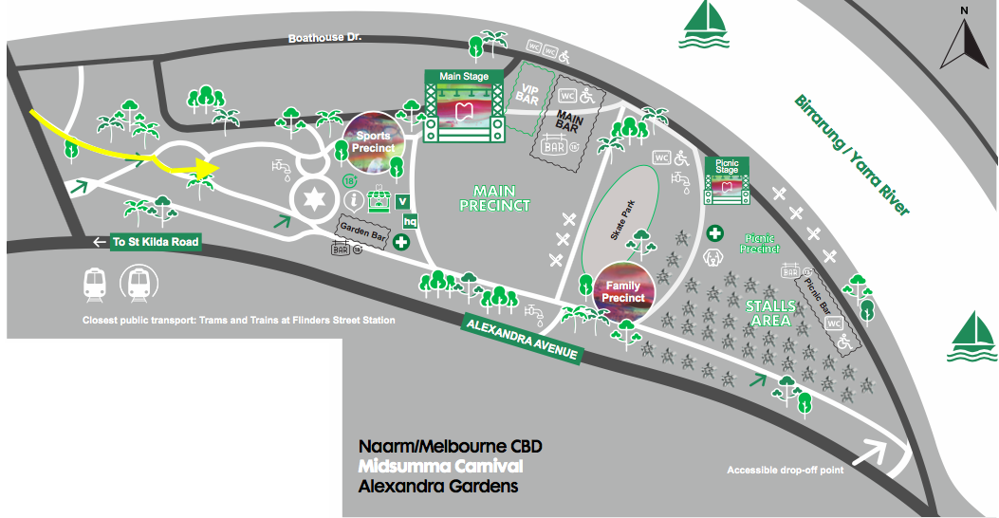

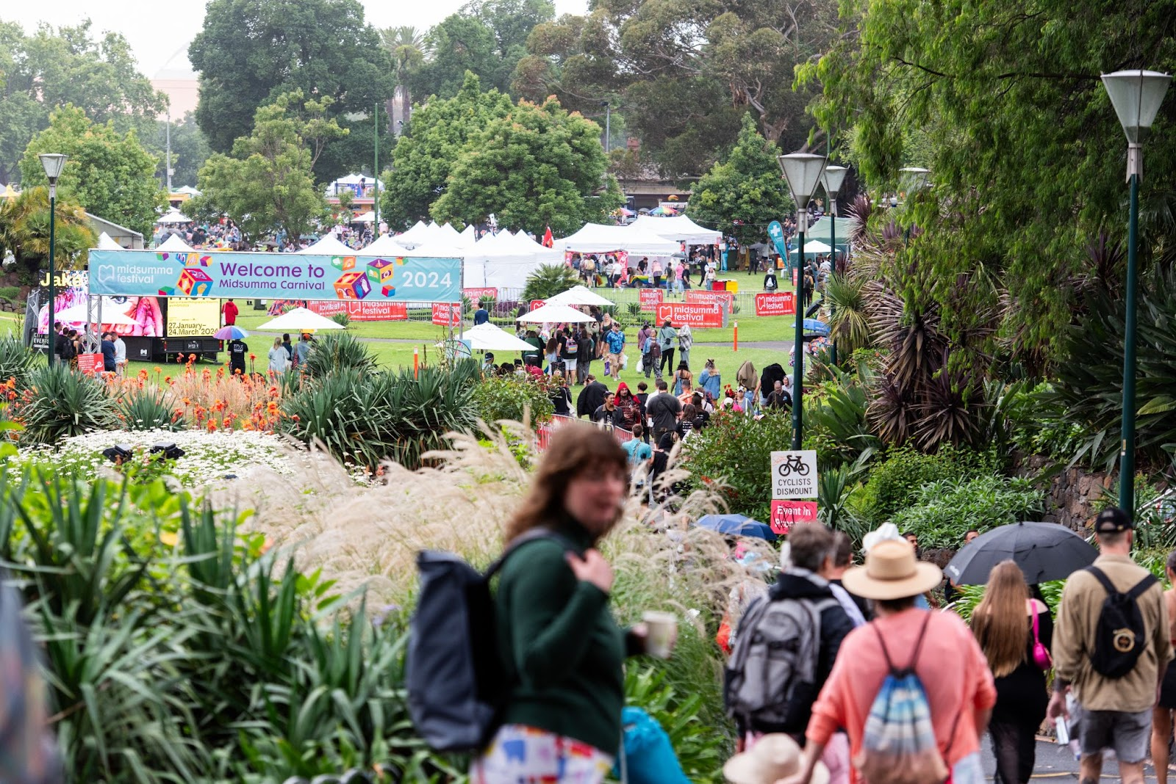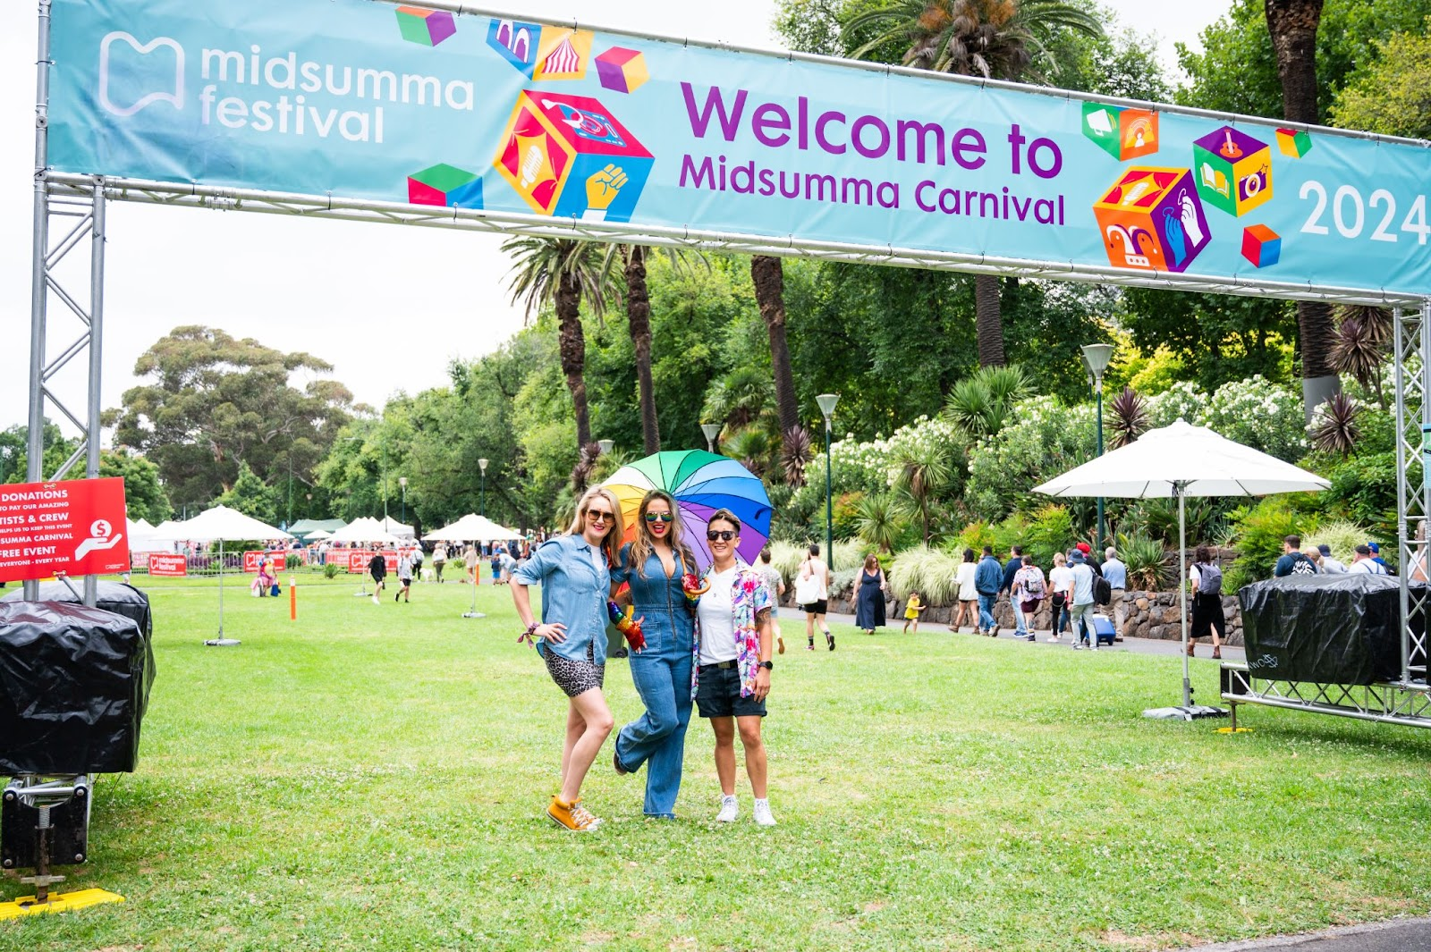

When I enter Carnival, I don’t need to pay any money. It is free.
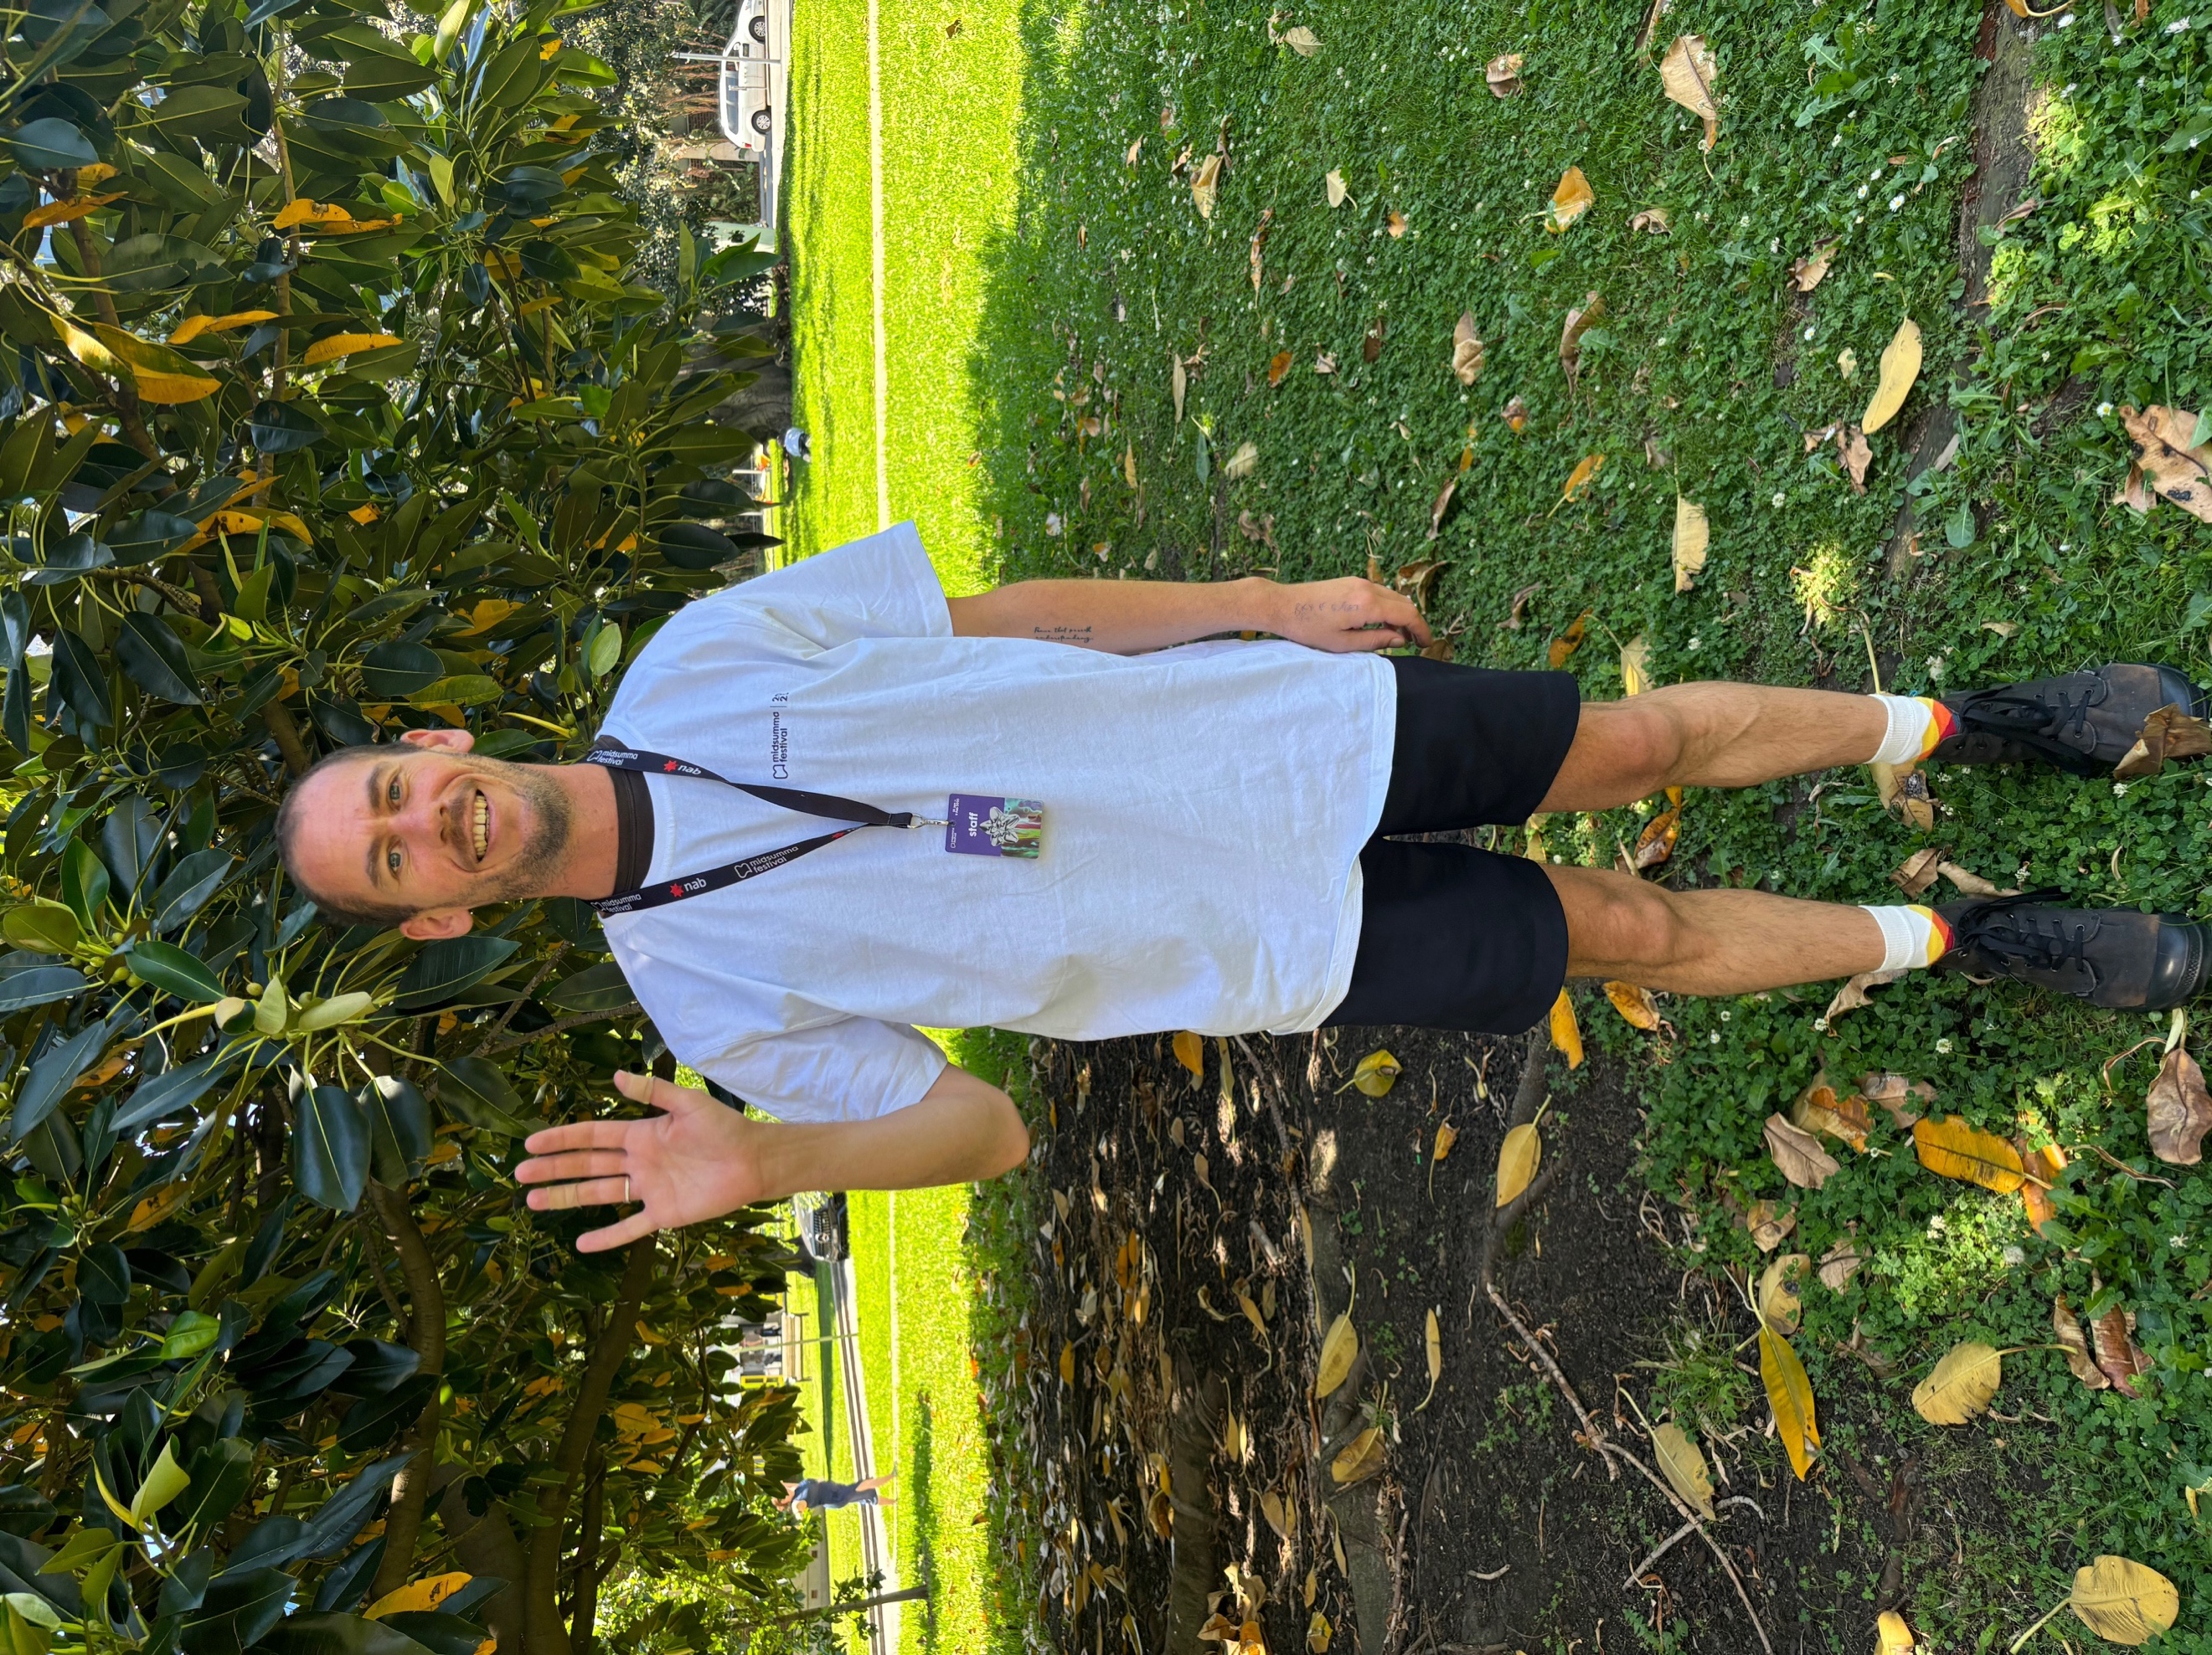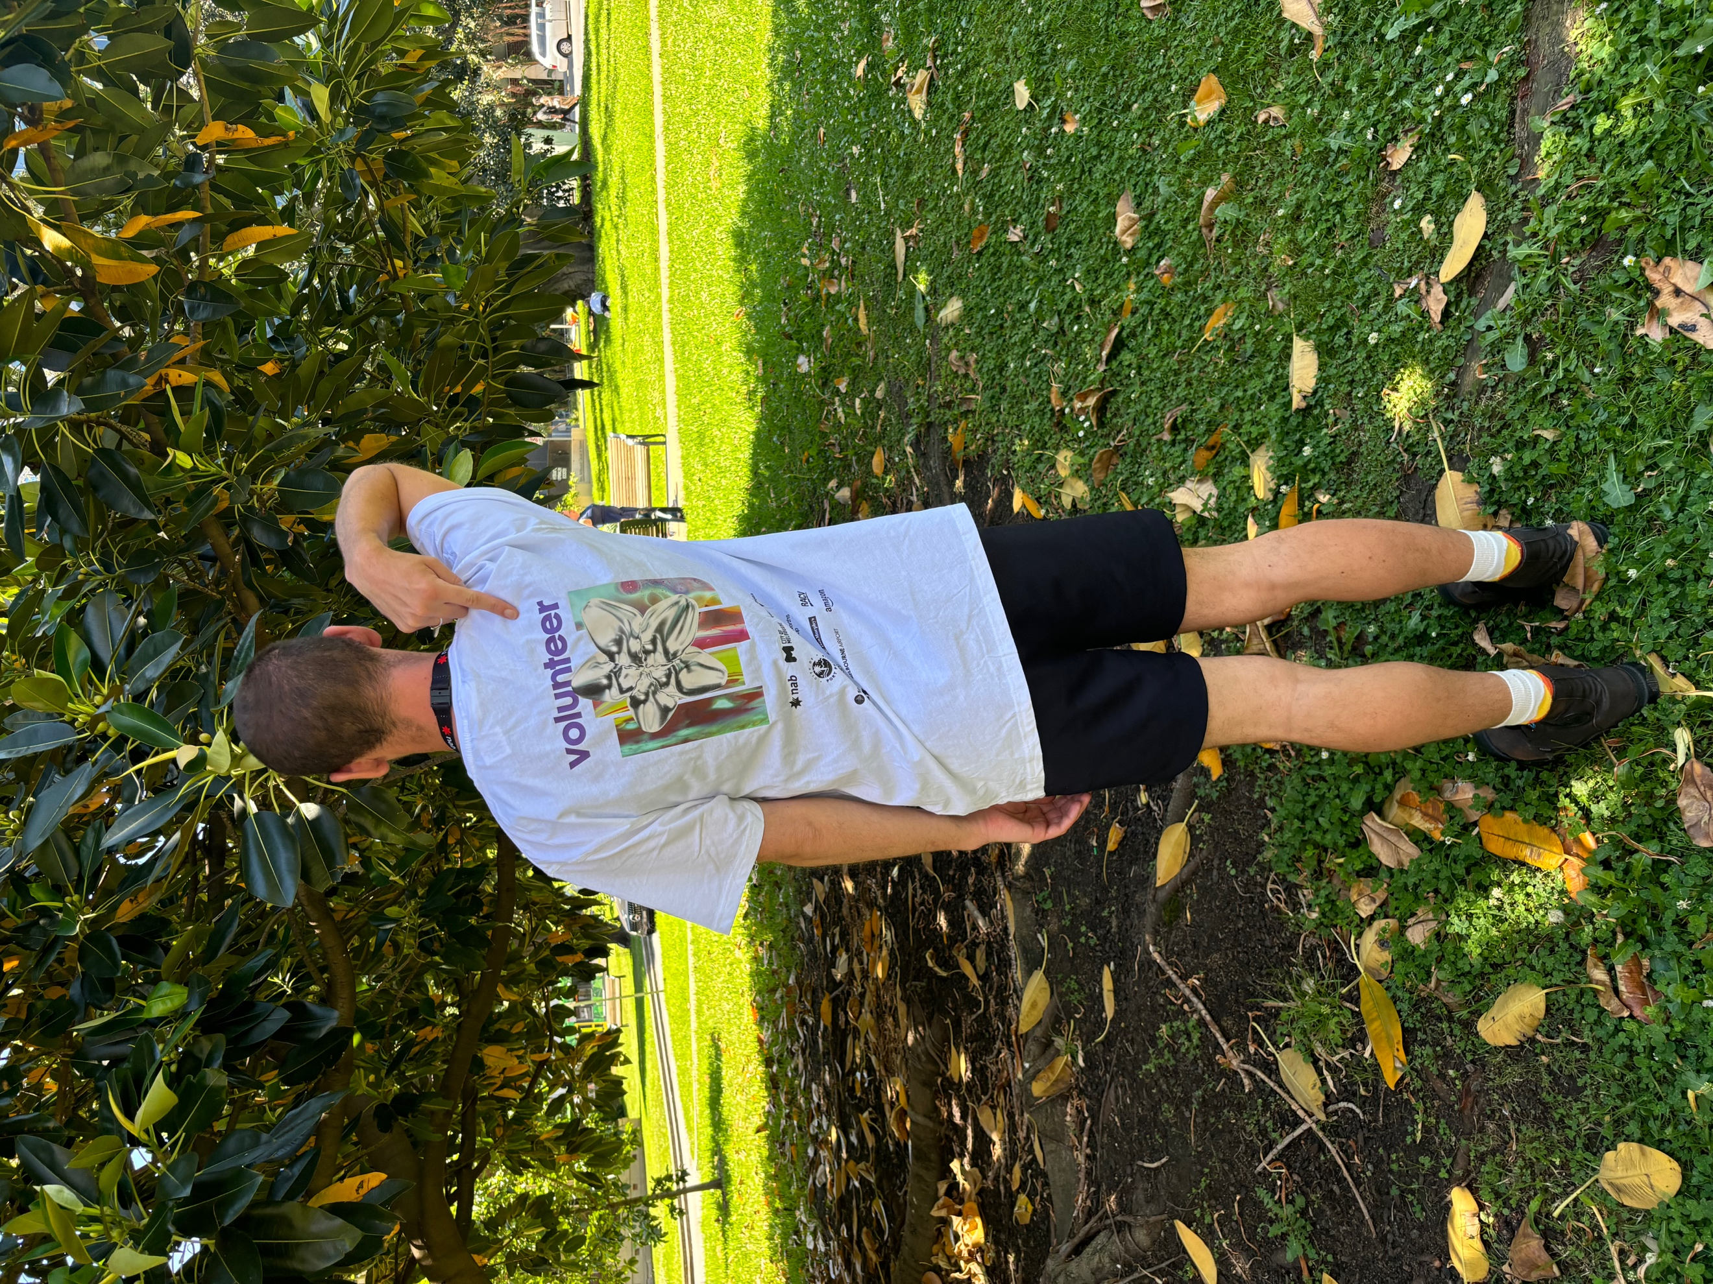

If I want information I can ask a volunteer. They will be wearing white t-shirts with VOLUNTEER written on the back.

QUIETER AREA

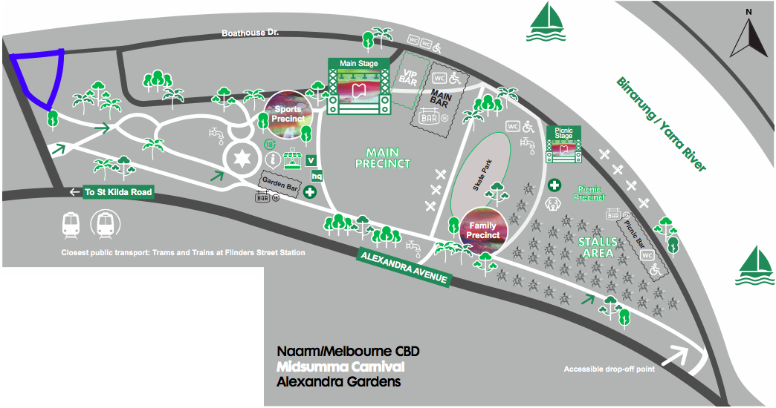

Midsumma Carnival is a high sensory environment. If I want to get away from noise or crowds, I can go to Peppercorn Lawn (highlighted in blue on this map) at any time. In the future, Midsumma Festival plan to provide a quiet room but it is not ready yet. This means that if I go to Peppercorn Lawn, I will still be outside.

WRISTBANDS

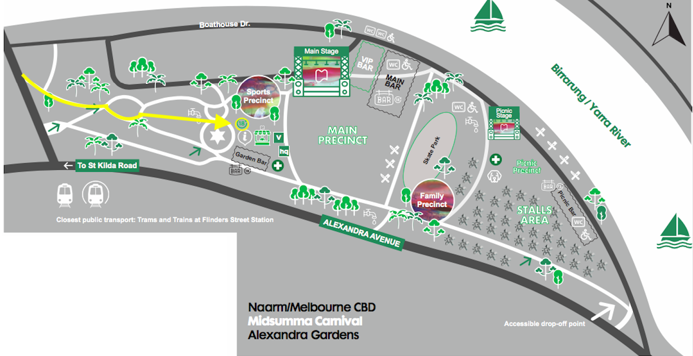

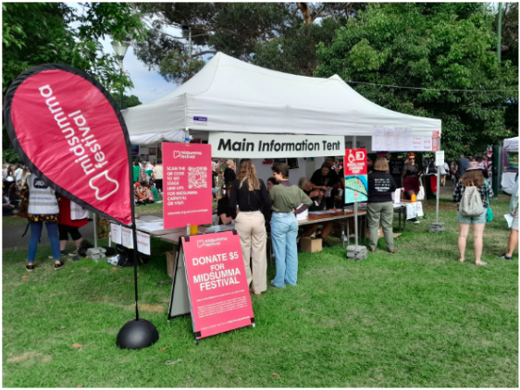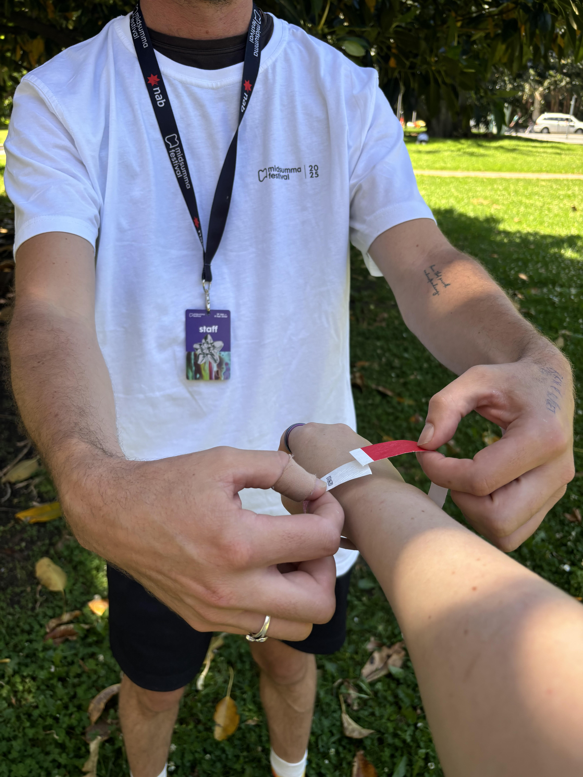

If I am going to buy an alcoholic drink later, I will need to get a red wristband from the main information tent after I enter Carnival. First, I might need to wait in line for up to 7 minutes. Then, a volunteer will ask me to show them my photo ID that proves I am 18 years or older. Next, they will help me wear a wristband.

SPORTS PRECINCT
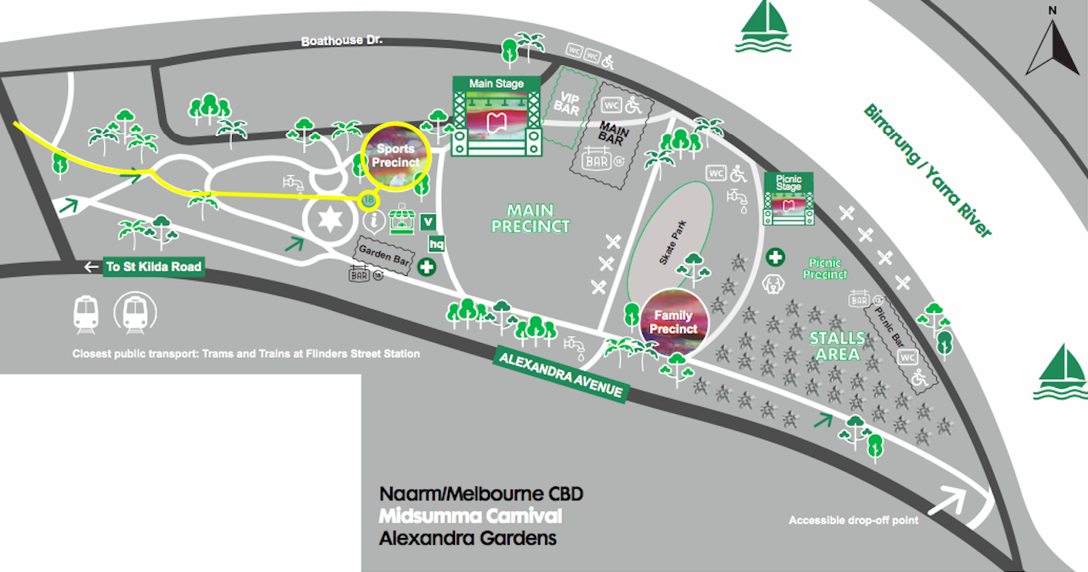
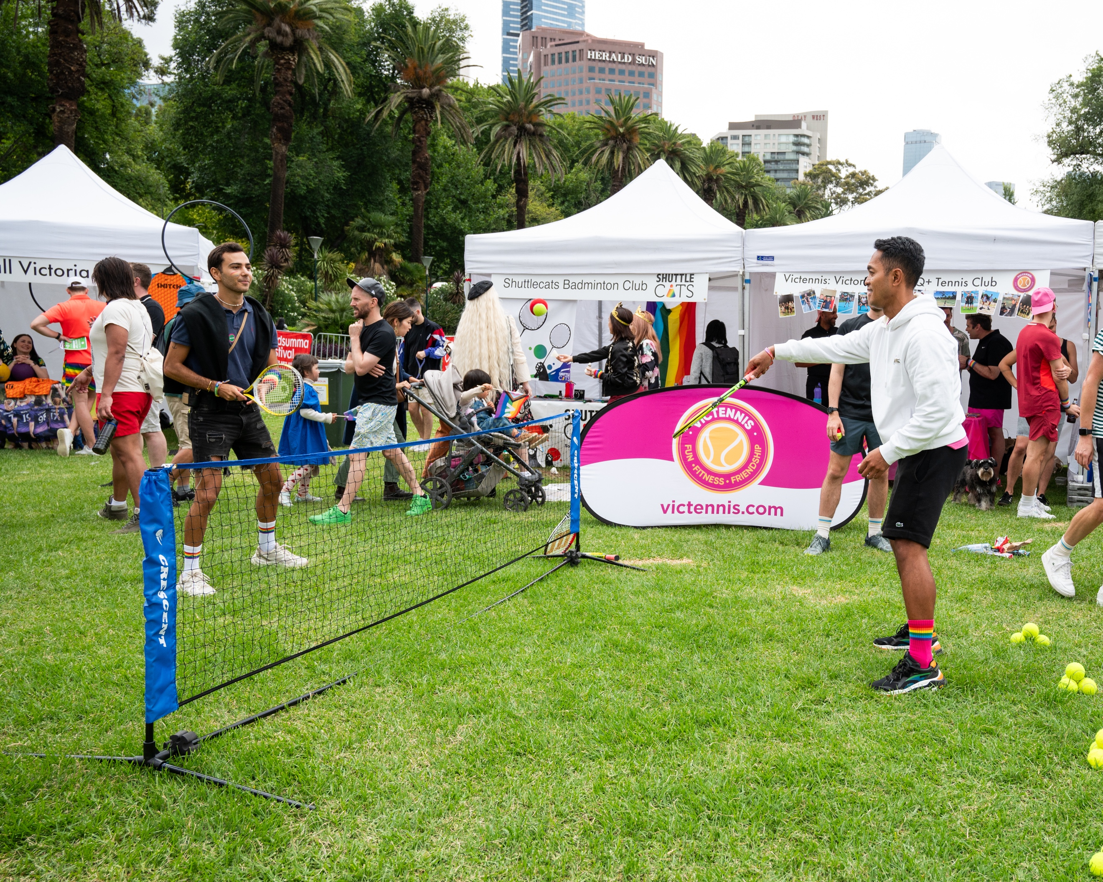
In the sports precinct, I can go to the white tents to get information about different sporting clubs that I might like to join in the future. I might be able to play a game with someone.

MAIN STAGE

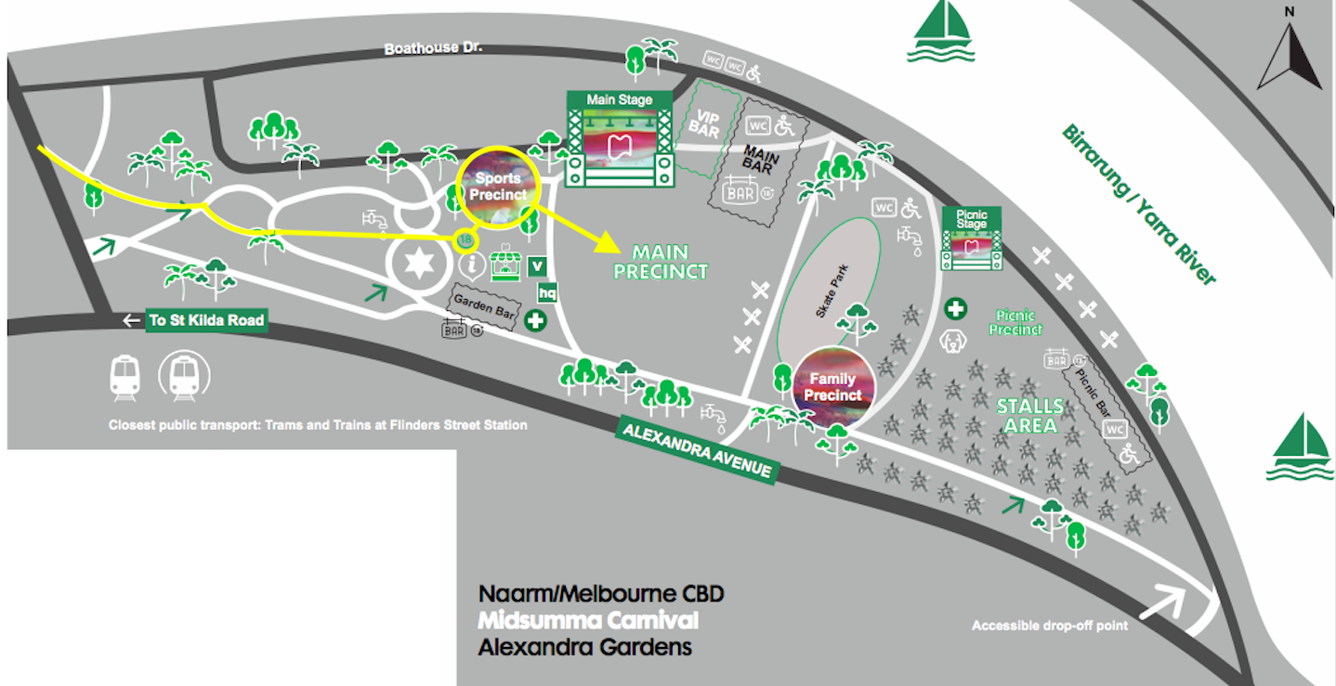

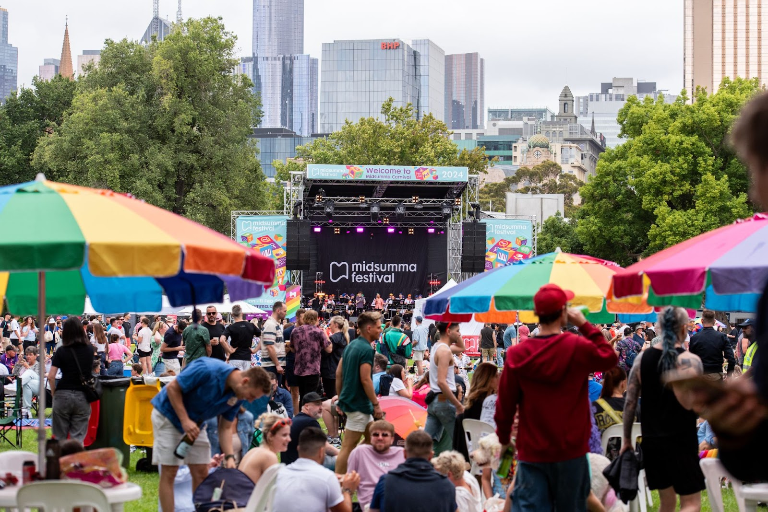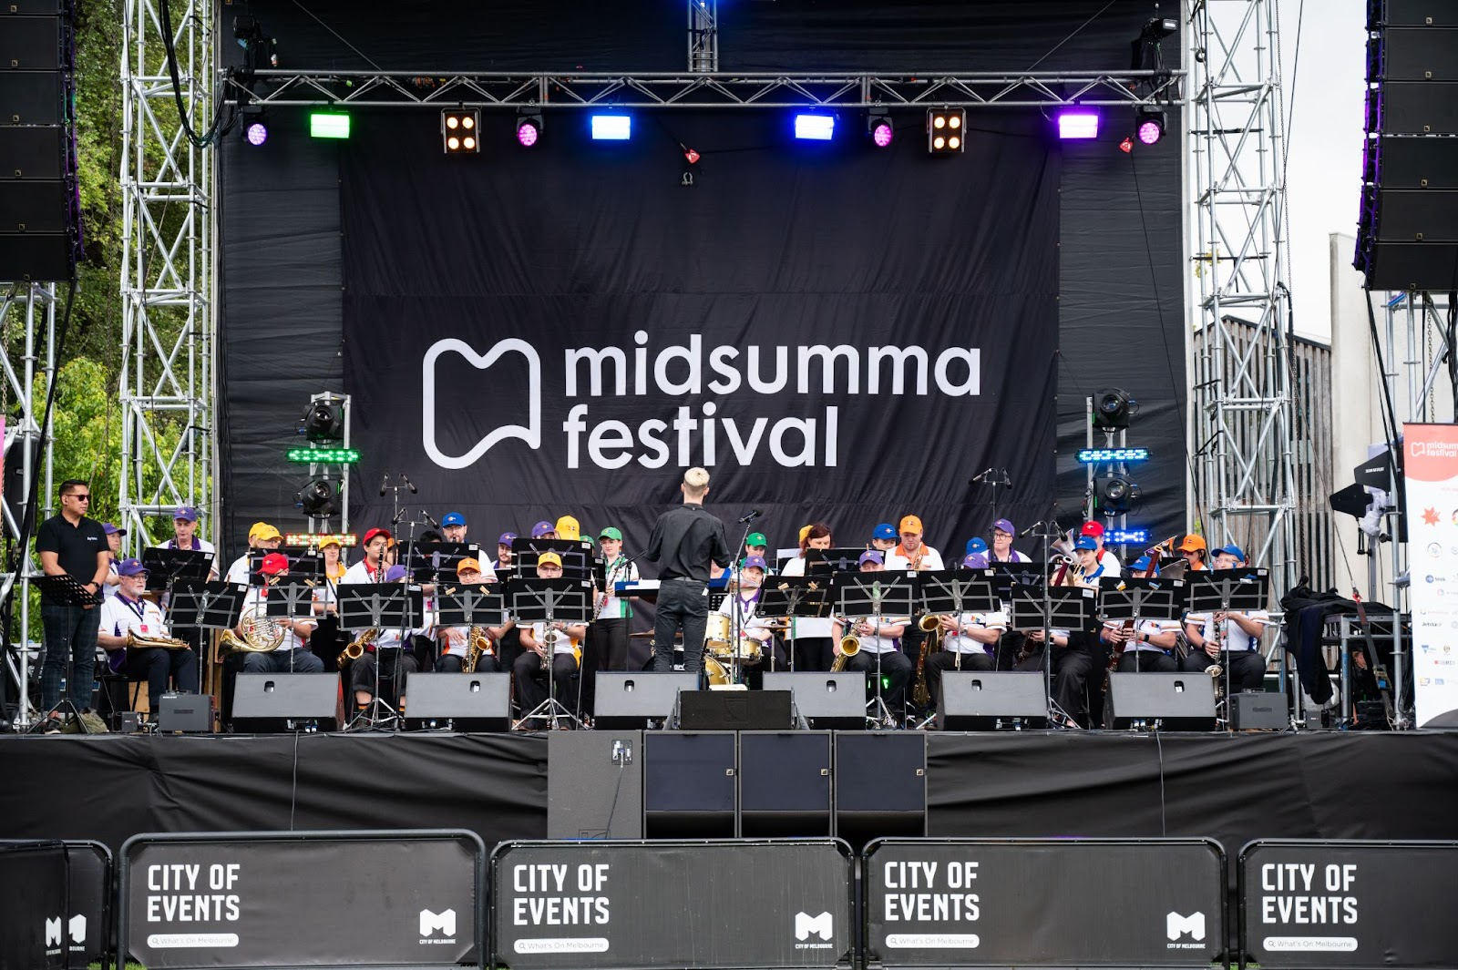

After the Sports Precinct, I can go to the Main Precinct to watch performances on the Main Stage. It will be loud. It might be very crowded.

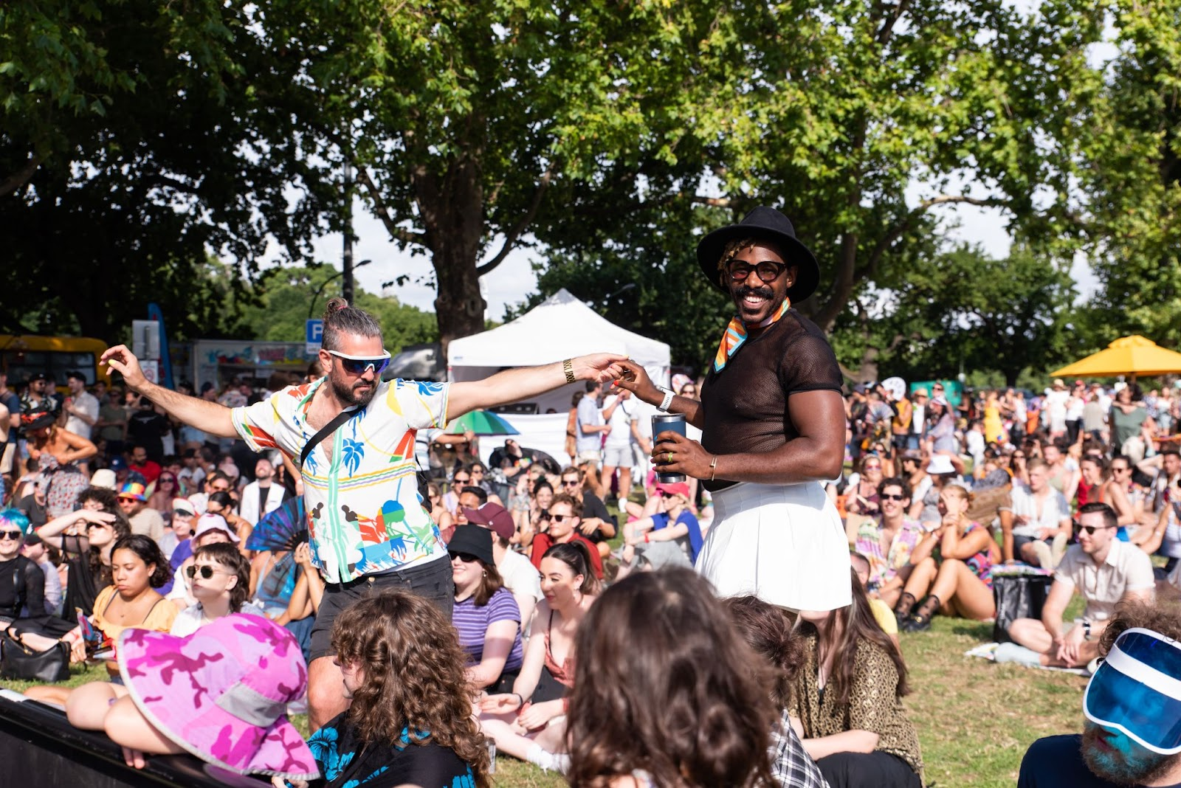

I can sit, stand, or dance.

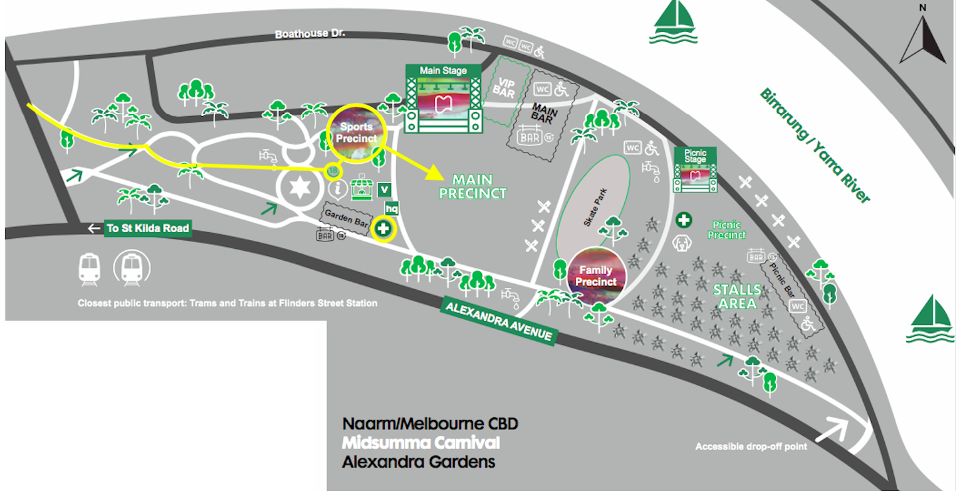
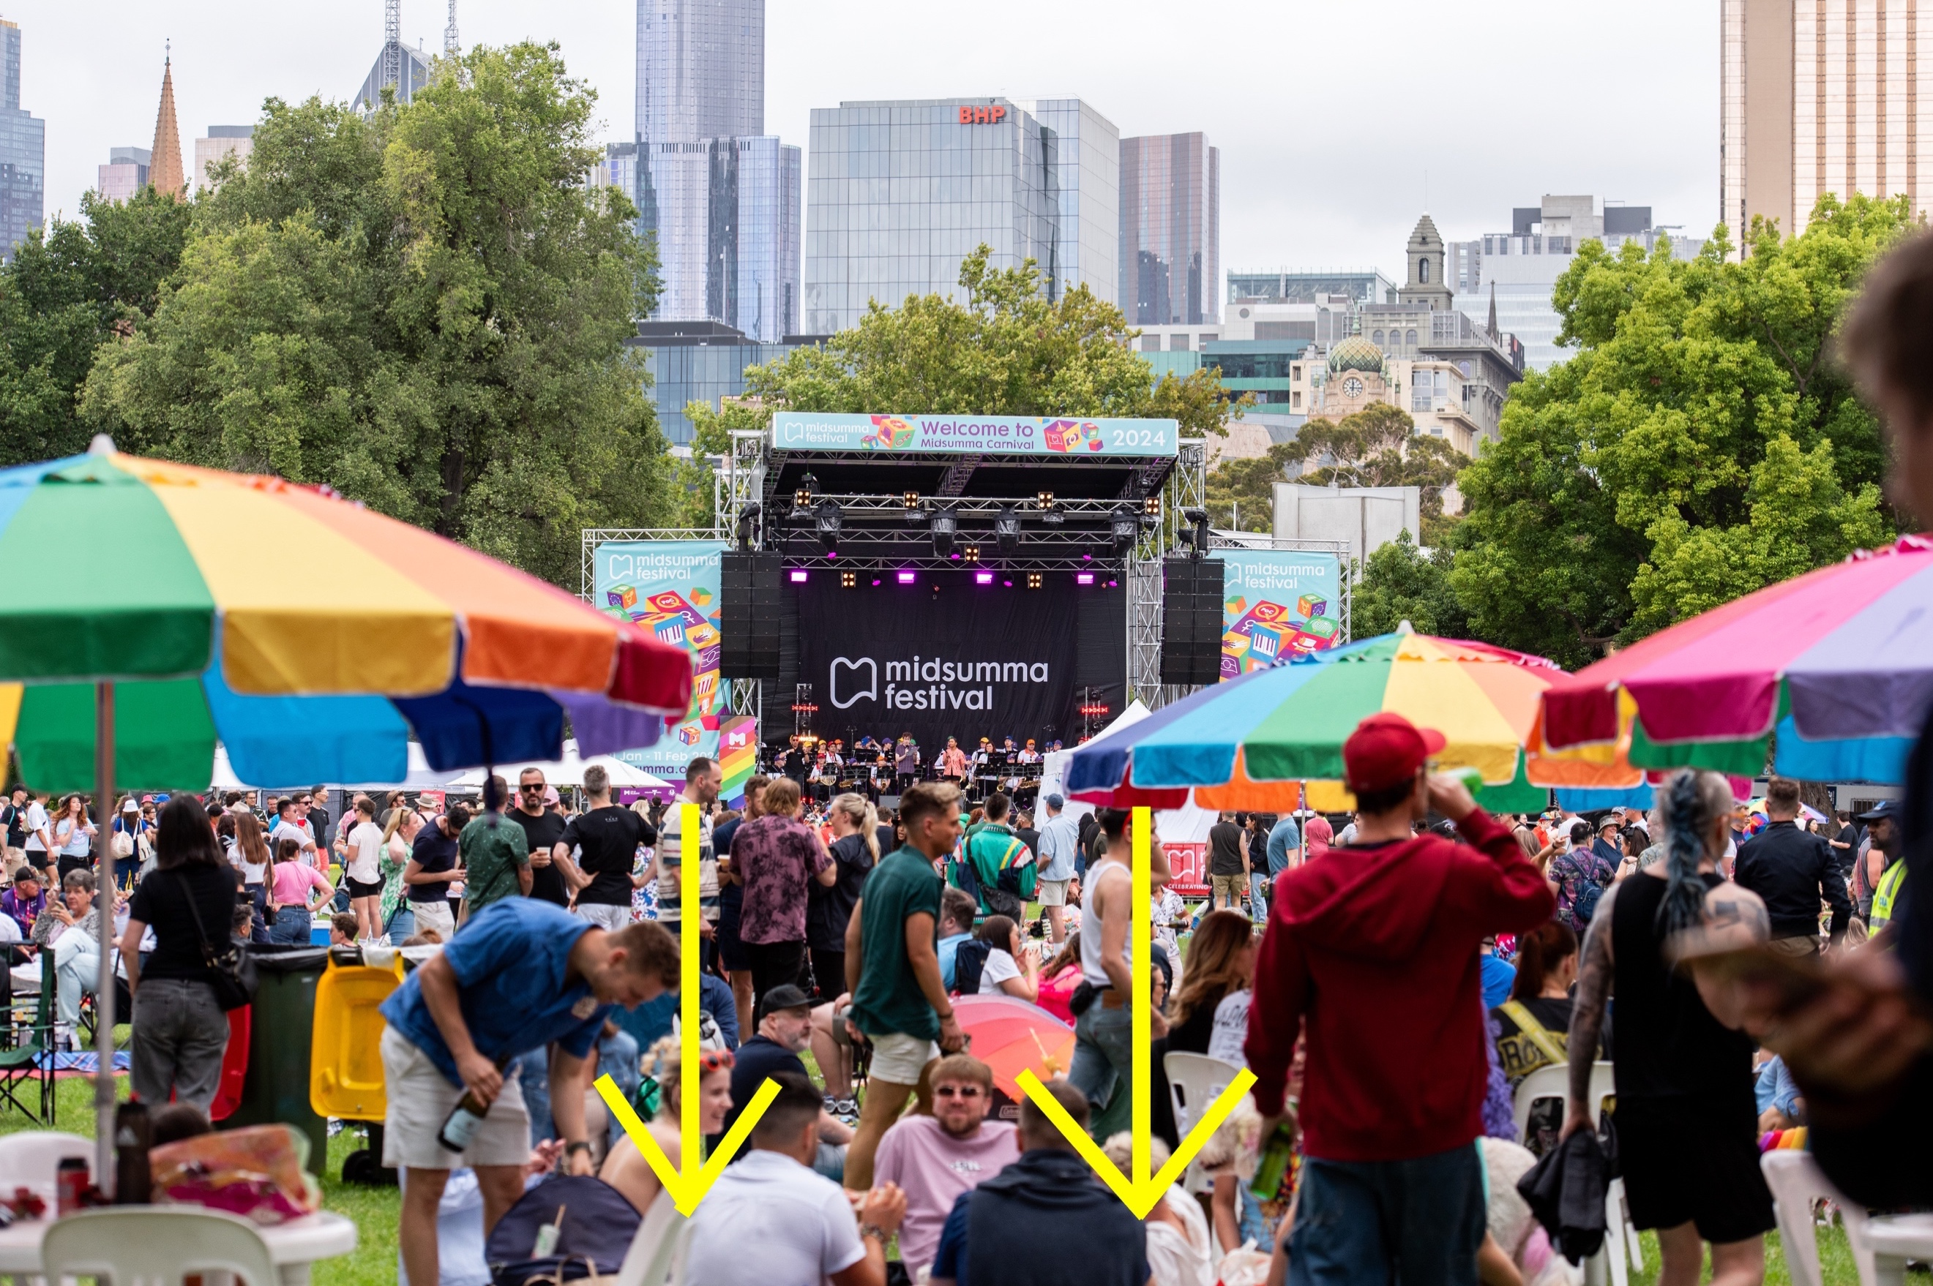
then 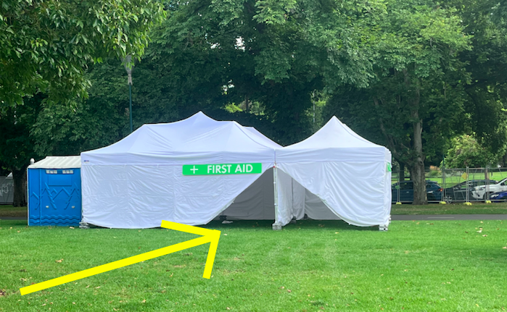

The First Aid Tent is located at the back of the Main Precinct. There will be staff here if I need first aid at any time.

QUIETER AREA

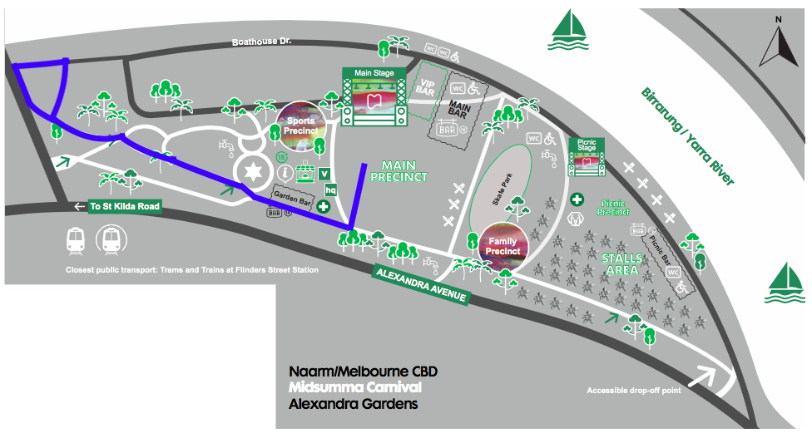

I remember that if I need a break I can go to the quieter area on Peppercorn Lawn at any time.

TOILETS
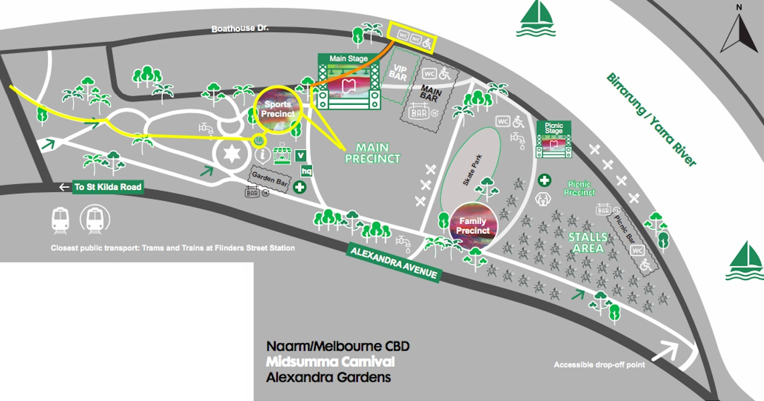

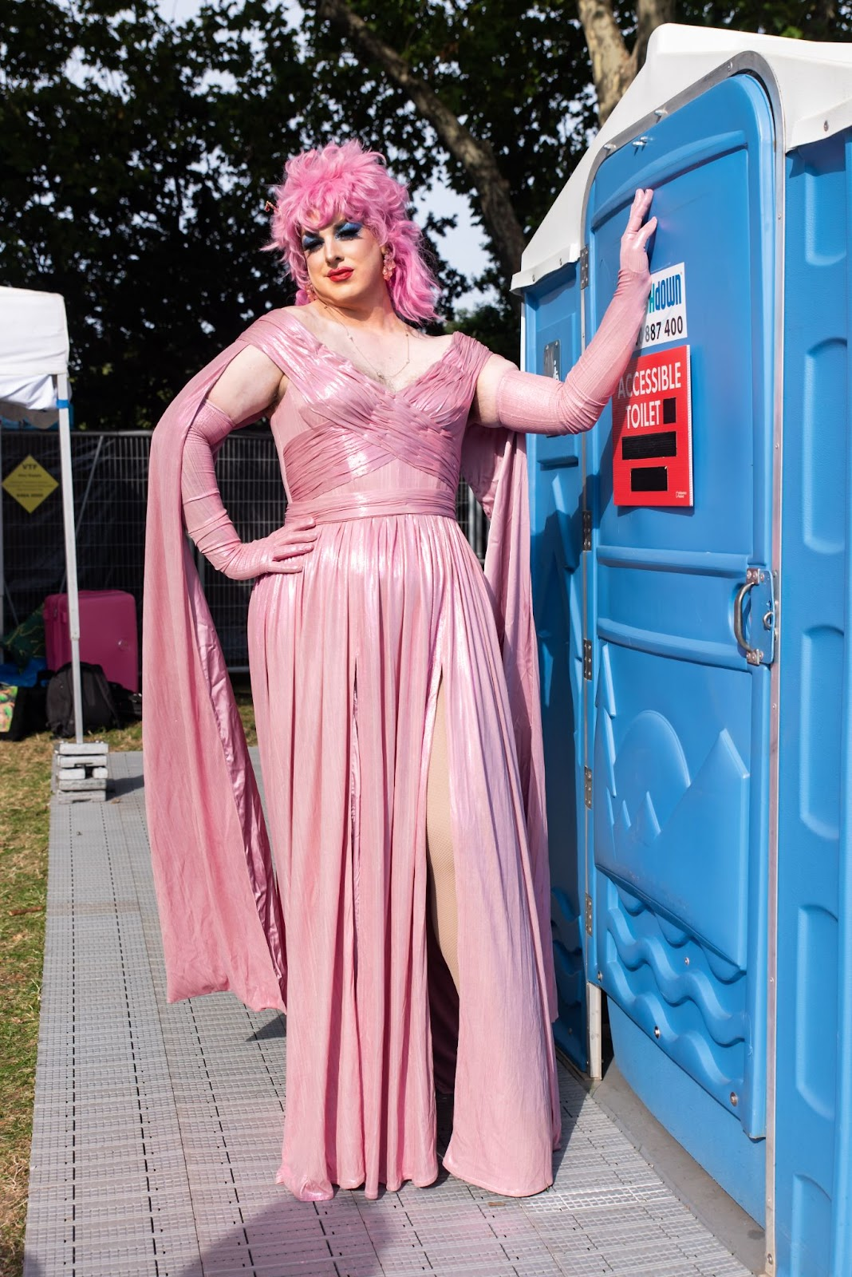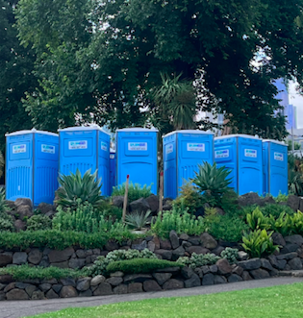

If I want to go to the toilet I can walk behind the main stage to the blue toilets. There will not be a drag queen standing out the front, leaning against the door.

MAIN BAR
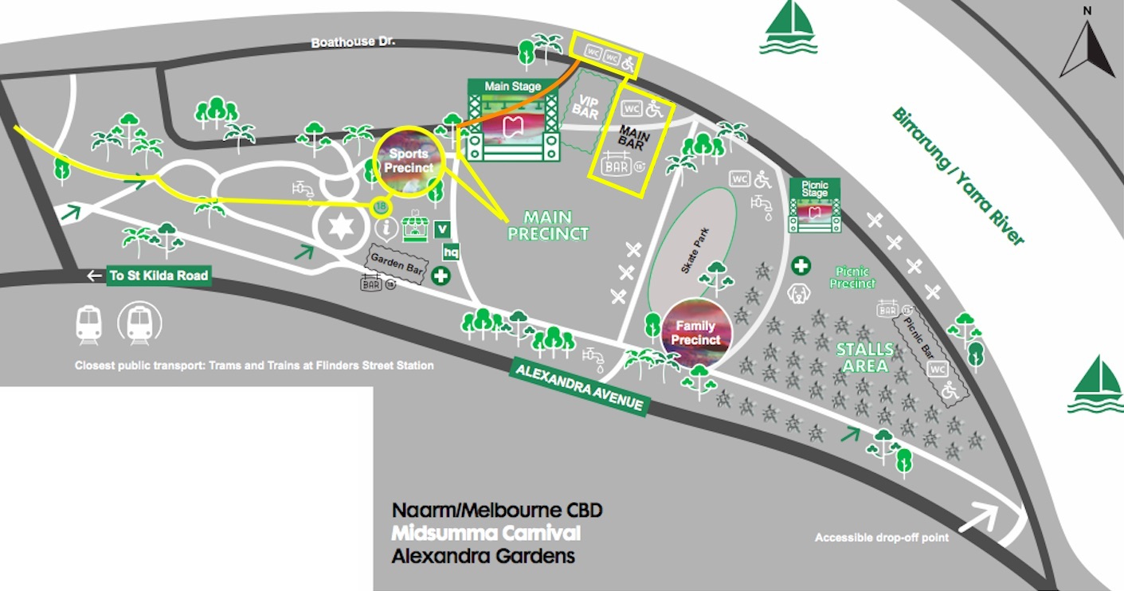

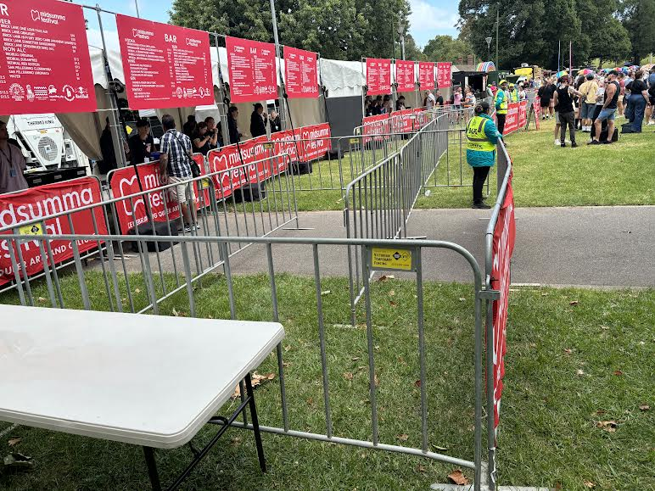

If I want to buy a drink I can buy one from the Main Bar. The person in the yellow vest is a security guard. They might ask me to show them my red wristband. After that, I can go to the bar and buy a drink.

WATER

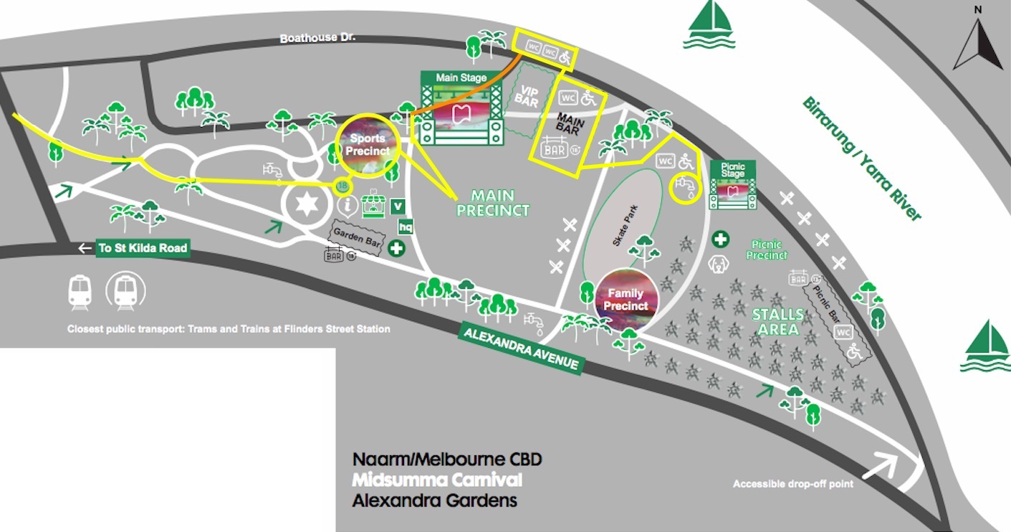

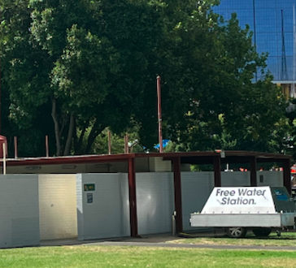

If I want to refill my water bottle I can do it at the free water station.

STALLS

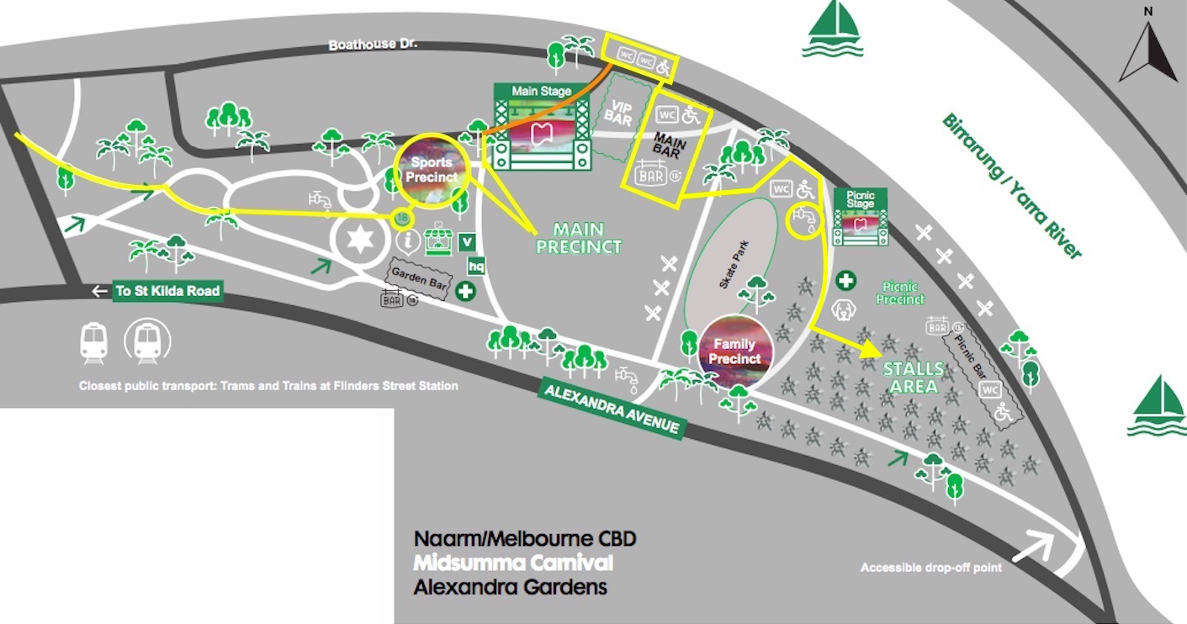
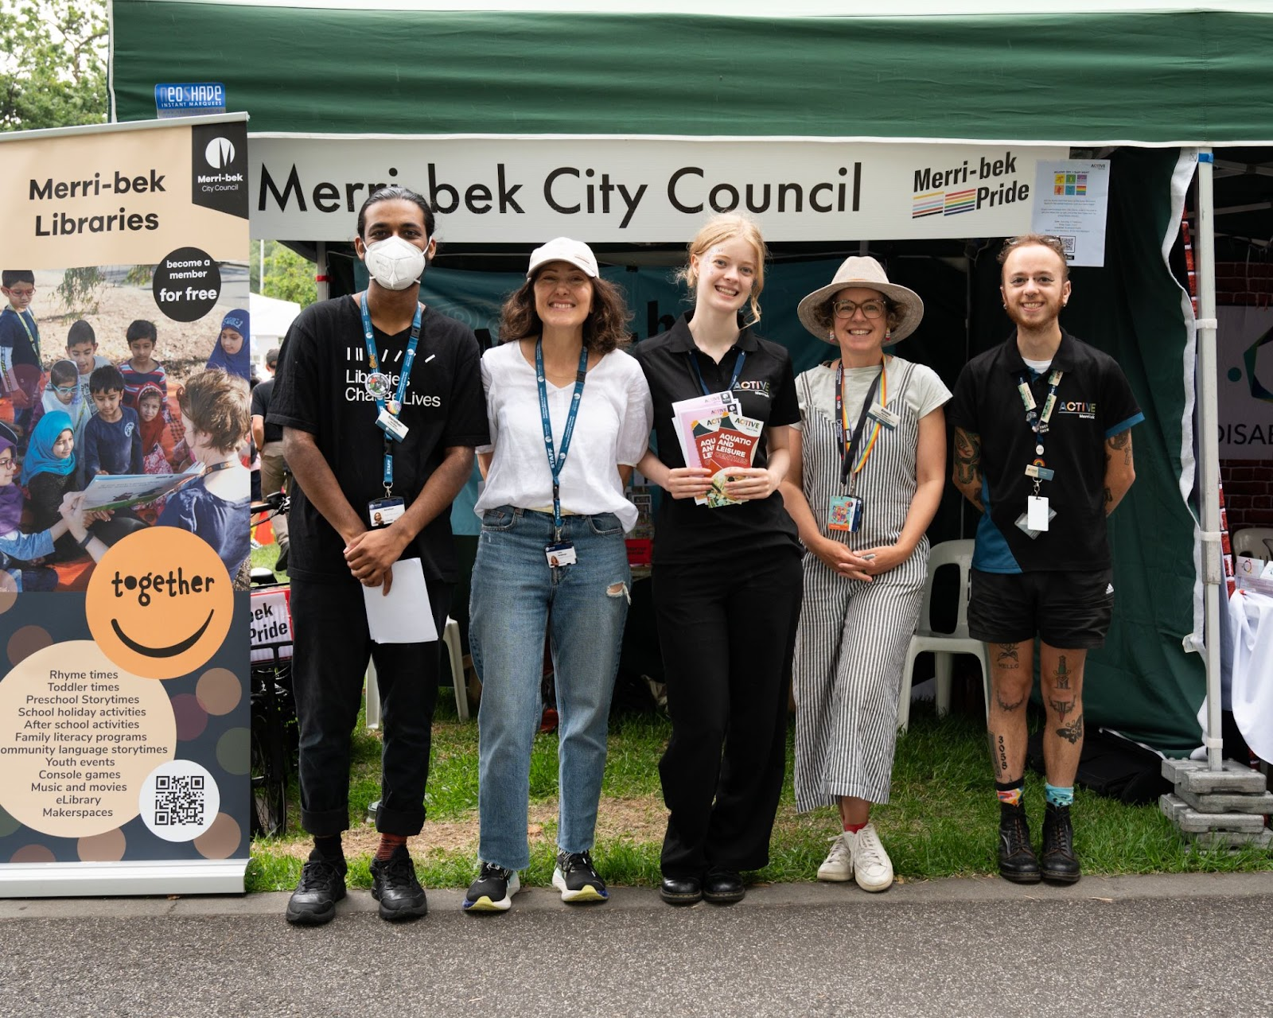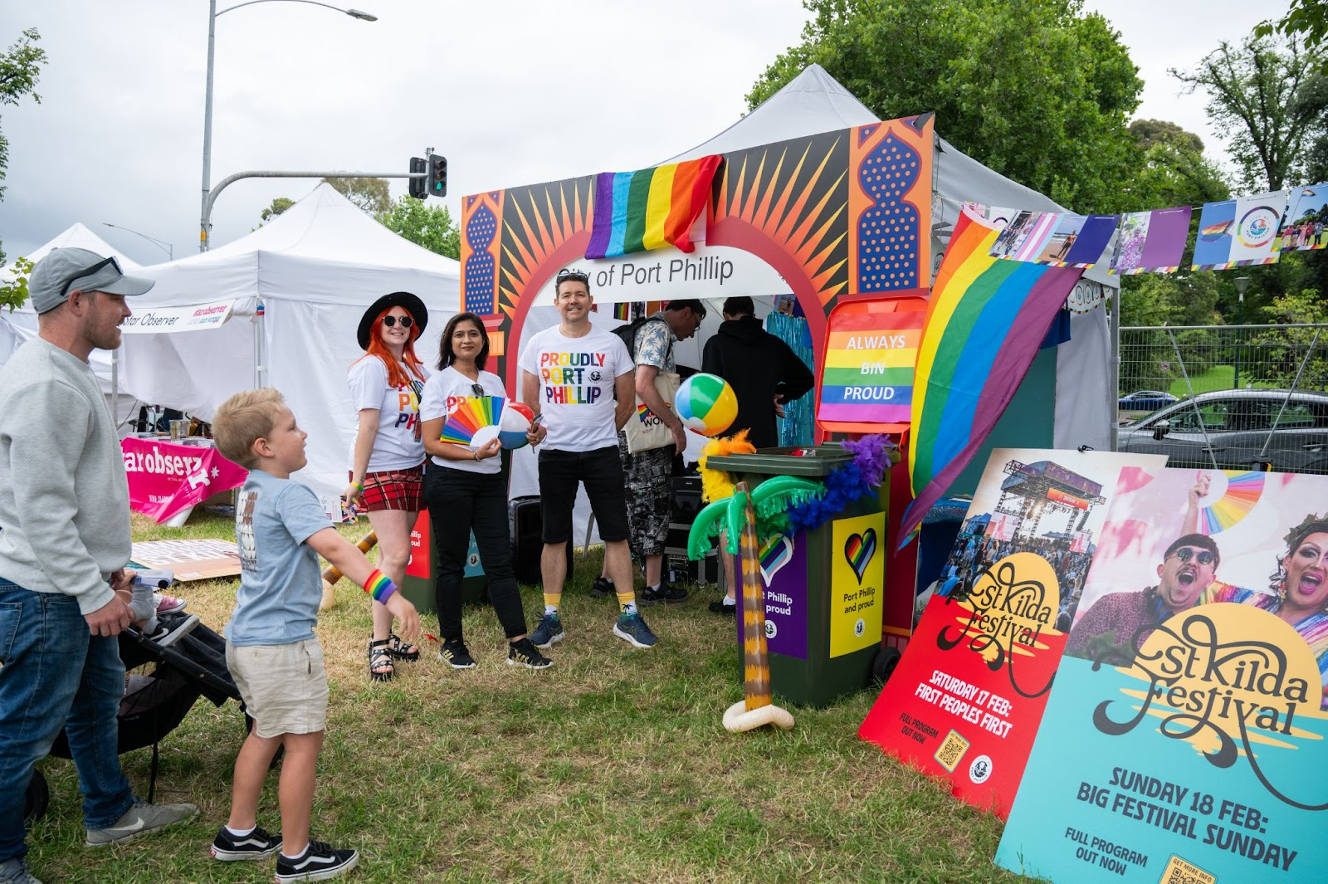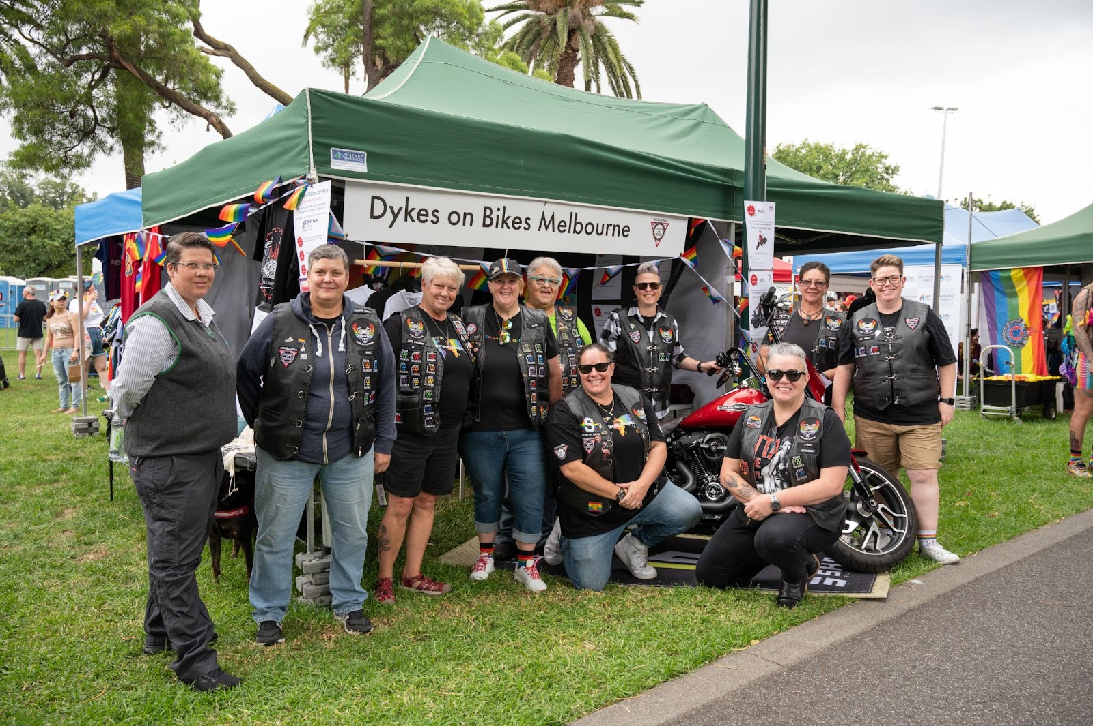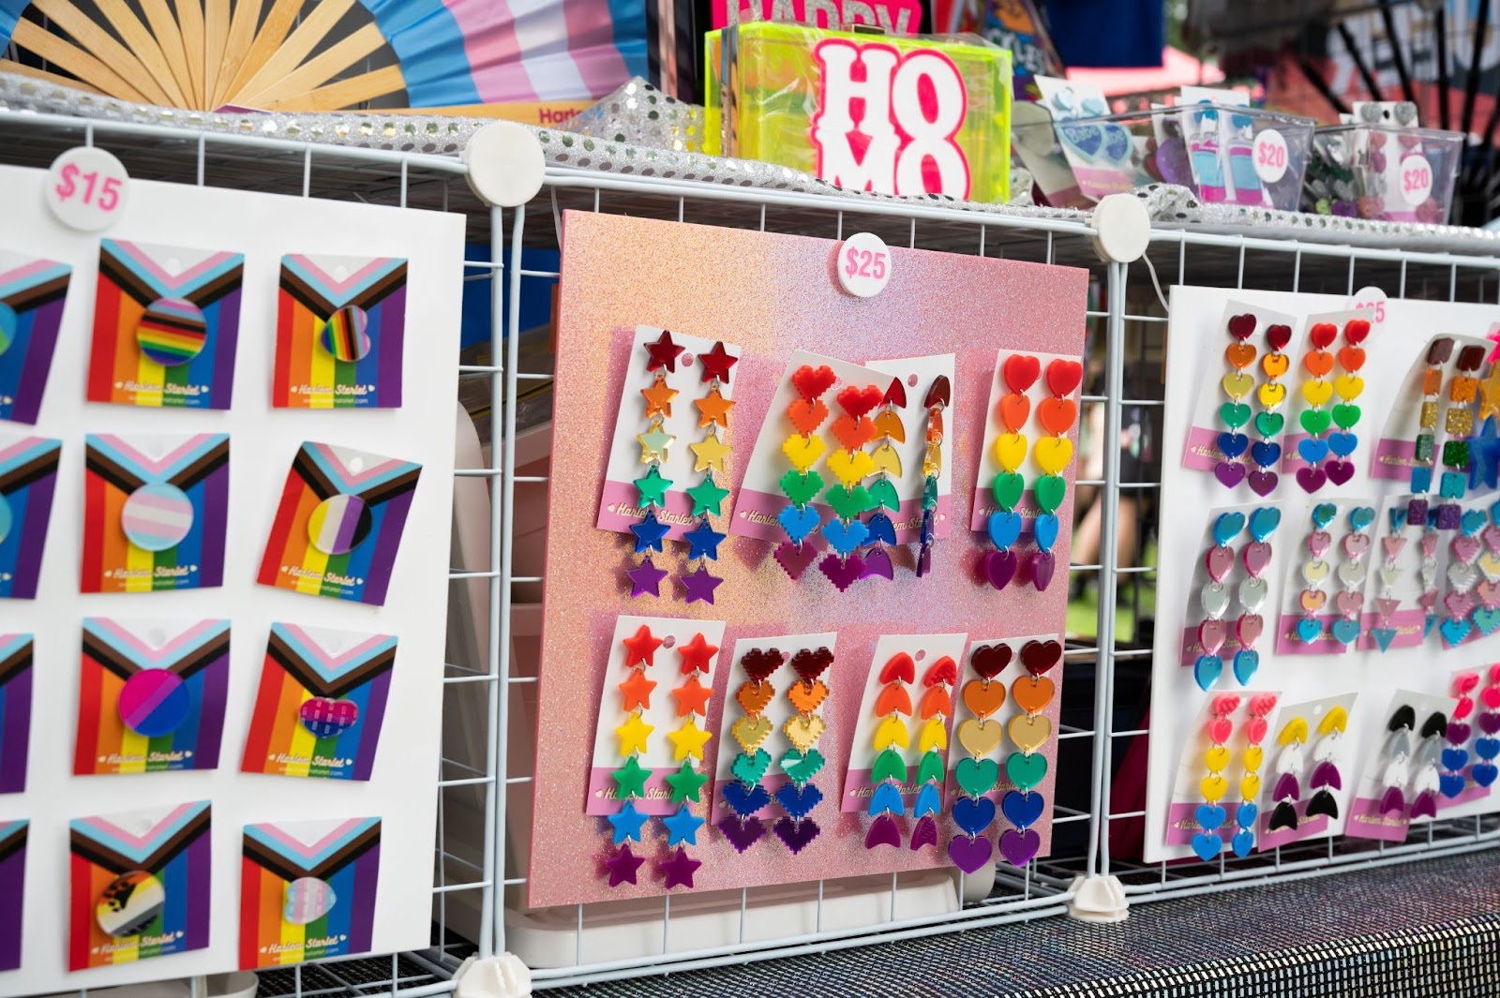

Next, I will go to the Stalls area. I might meet people from different community groups. The name of their group will be written on a sign at the top of their tent. They might give me things for free, but if I don’t want these things I can say ‘No’.

FOOD TRUCKS

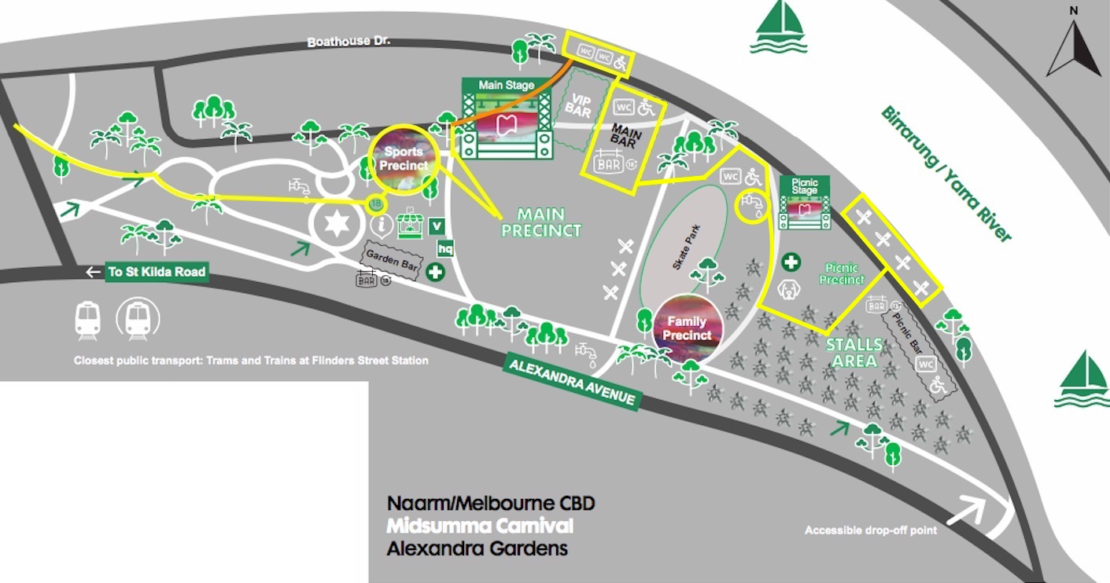

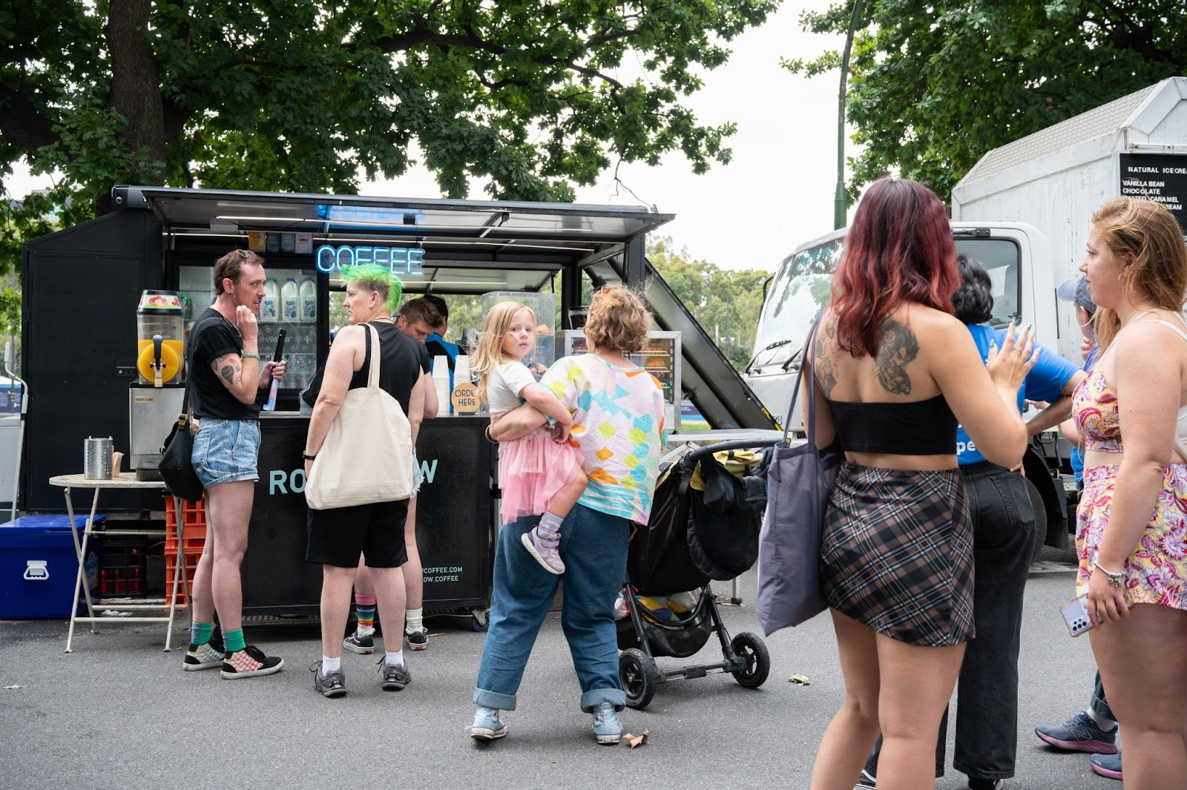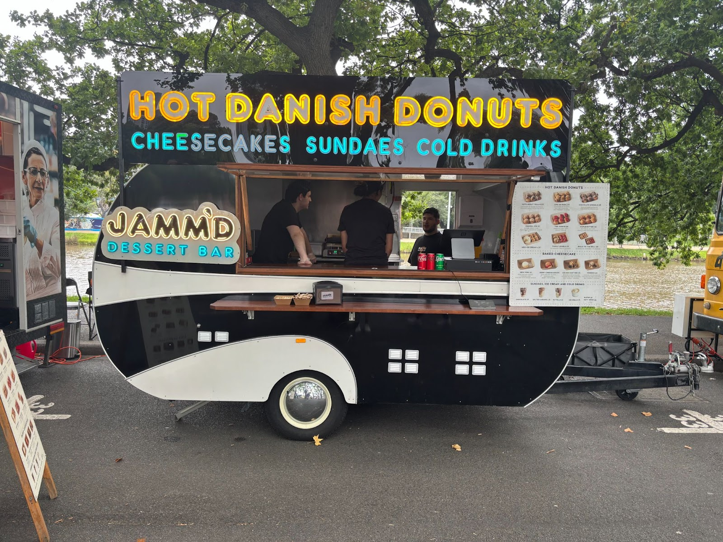

If I am hungry I can buy food from one of the food trucks. There will be lots of food options. From 1pm onwards there can be long lines at the food trucks and I might need to wait for 10 minutes.

PICNIC STAGE

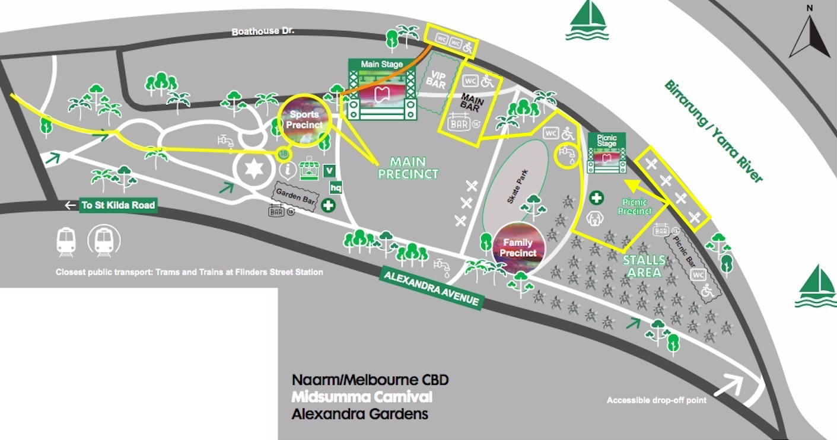

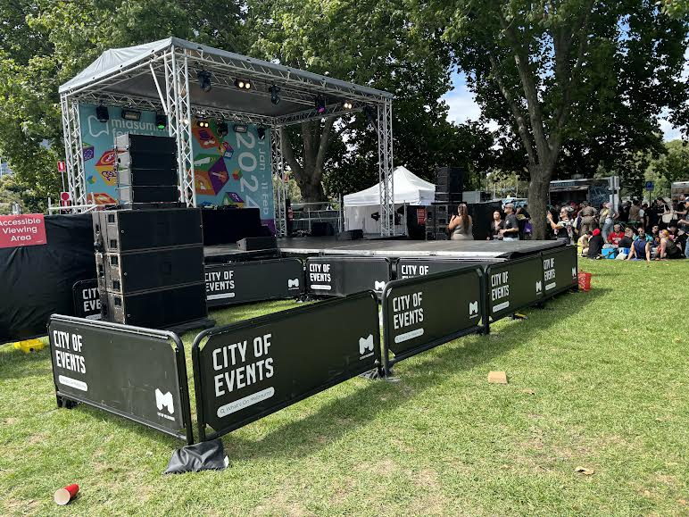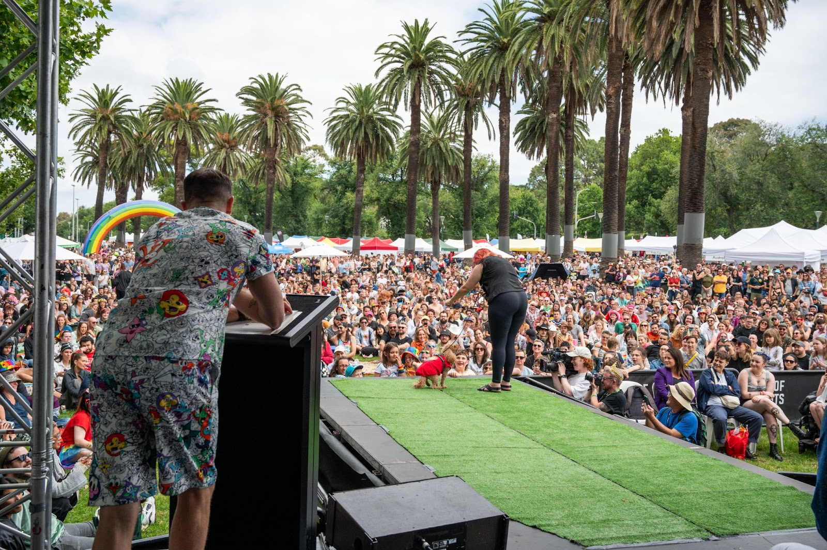

The picnic stage is smaller than the Main Stage. If I am here at 3pm, I will see the Dog Show, which is when owners bring their dogs on stage to show them to the crowd. It is a competition, and some dogs get prizes.

POLICE

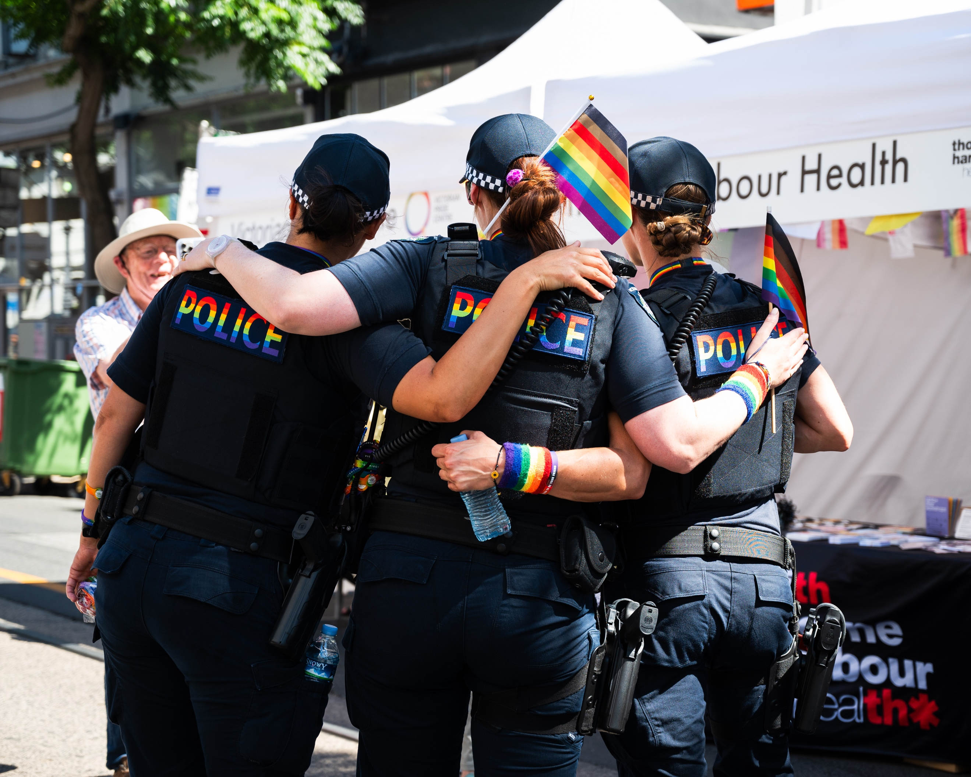

Police will be at Midsumma Carnival and I might see them.
FURTHER ASSISTANCE

When I am at Carnival, I can text or call Midsumma’s access hotline if I want information or assistance, or if I have questions. The phone number is 0437 557 109. Josh or Harriet will answer.

FEEDBACK AND QUESTIONS

I can email admin@midsumma.org.au or call 9296 6600 if I have any questions or feedback.

Or, I can scan this QR code to fill out a feedback form:

